**Module 8: Final Project**

**Submitted By: Praveen Kumar Siddela**

**IFT 458 & IFT 554: Middleware Programming & Database Security**

**Dinesh Sthapit**

**Due Date: 04/26/2024**

**Introduction**

**Overview of the project**

The project's objective is to create a Book Exchange Application facilitating users to list and exchange books seamlessly with their peers. It's designed as a lightweight web application prioritizing smooth user experiences for registration, password management, and book listing. Following the MVC (Model-View-Controller) pattern in its architecture ensures scalability and maintainability by separating concerns effectively.

**Problem Statement**

Conventional book exchange methods are inefficient and inaccessible, often relying on physical meetings or complex online platforms. This initiative aims to overcome these shortcomings by offering a digital platform where users can effortlessly list their books, explore available titles, and initiate exchanges with others. The aim is to simplify the book exchange process, making it convenient and accessible to a broader audience.

**Scope and Limitations**

The project encompasses developing a web-based application featuring user authentication, book listing, and exchange functionalities. Users can register, log in, list their books, browse titles, and initiate exchanges. However, the application doesn't handle physical book shipments or payments; it solely facilitates the exchange process by connecting users based on their preferences.

**Justification of the Technology Stack Used**

The technology stack comprises Node.js for server-side development, Express.js for constructing the web application framework, MongoDB for efficient data storage, and EJS (Embedded JavaScript) for server-side templating. These technologies were chosen for their reliability, scalability, and user-friendly nature in web application development. Node.js and Express.js offer a lightweight and effective server environment, while MongoDB ensures flexibility and scalability in storing user and book data. EJS enables dynamic content rendering on the server side, enhancing user interaction.Top of FormBottom of Form

**Architecture Diagrams**

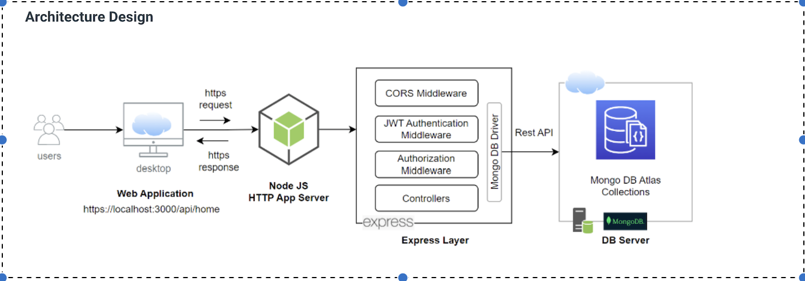

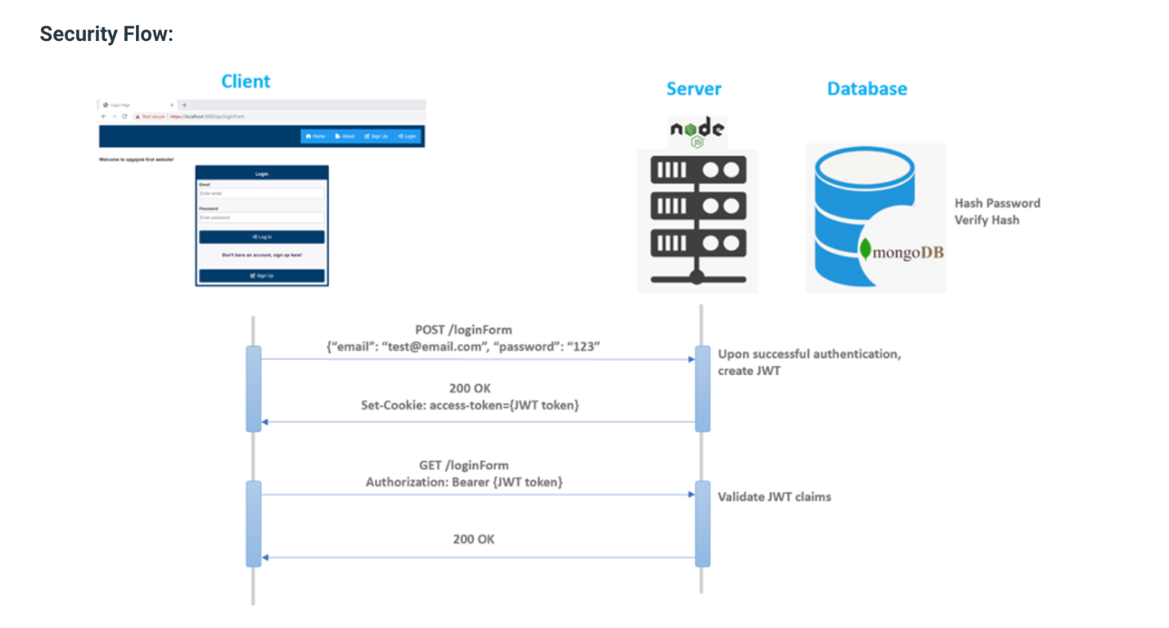

**Flowchart**

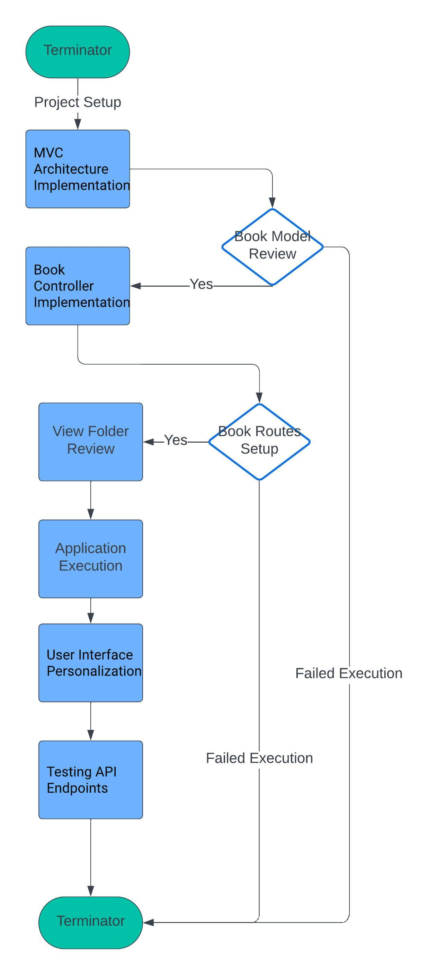

**Pseudocode:**

**// Server-side Process:**

1. Respond to incoming requests along specified routes.
2. Determine the appropriate controller function for each request.
3. Handle data processing and interaction with the model.
4. Formulate and dispatch responses back to the client.

**// Model (Data Management):**

1. Establish structured schemas for book and user data representation.
2. Develop methods to execute database operations, including creation, retrieval, updating, and deletion.
3. Implement procedures for data validation and manipulation.
4. Provide processed data to the controller for further handling.

**// Client-side Actions:**

1. Dynamically construct user interface components based on application state.
2. Monitor and respond to user interactions, like form submissions and button clicks.
3. Initiate relevant actions, such as sending requests to the server, upon user interaction.
4. Reflect updates to the interface in accordance with server responses.

Top of Form

Bottom of Form

**Code Snippets:**

**bookExchangeForm.ejs**

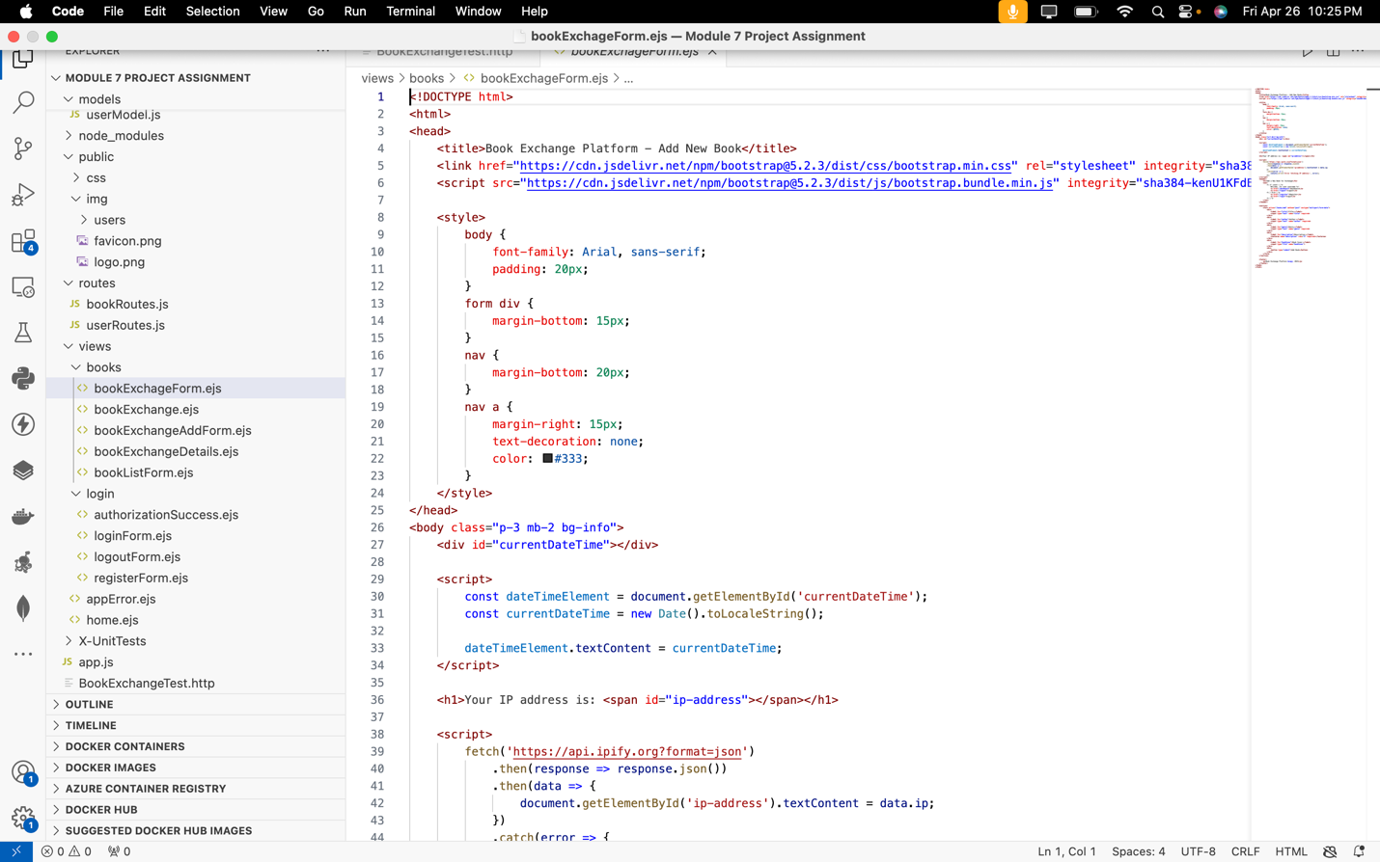

1. **Form Submission:** The <form> element defines a form for submitting book details to the server. It specifies the action attribute as "/books/add" for sending the form data to the appropriate endpoint on the server.
2. **Input Fields:** Various <input> elements are used to capture information about the book, such as title, author, genre, and description. The required attribute ensures that these fields must be filled out before the form can be submitted.
3. **File Upload:** An <input type="file"> element allows users to upload a book cover image along with the other details.

**bookExchange.ejs**

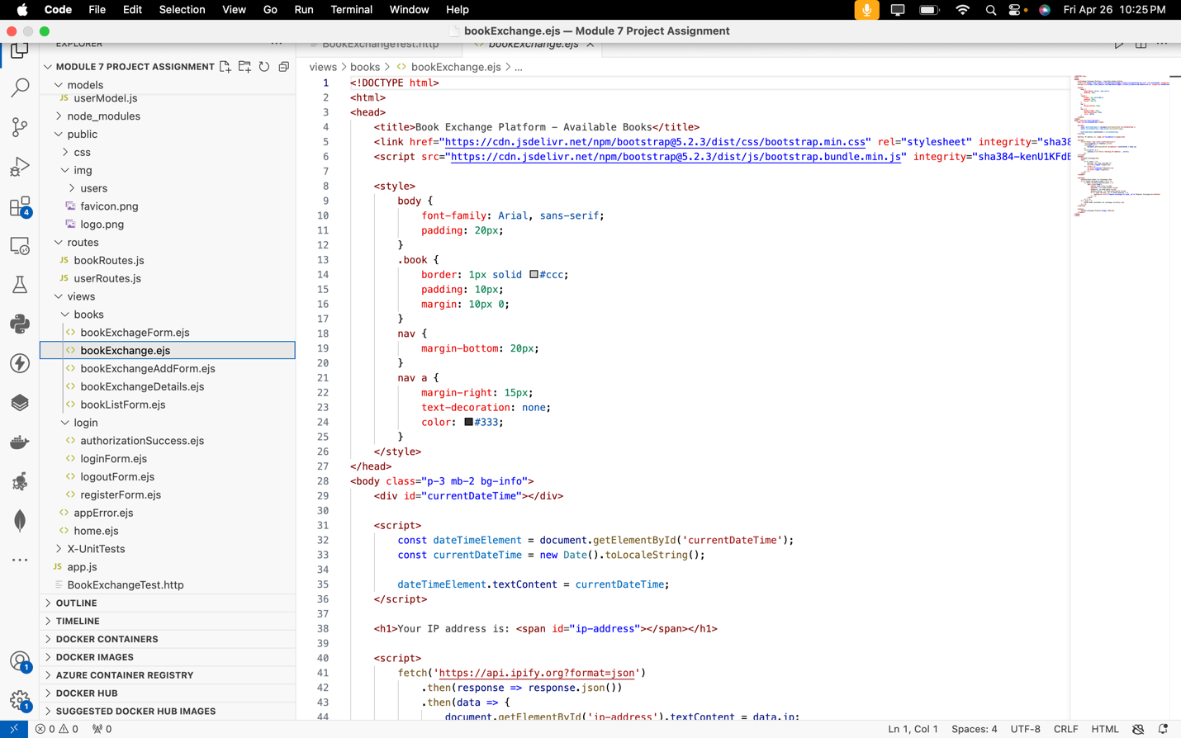

1. **Error Handling:** The Fetch API is used to asynchronously fetch data from an external API (https://api.ipify.org?format=json). Error handling is implemented to catch and log any errors that may occur during the fetch operation.
2. **Footer:** The <footer> section provides copyright information for the Book Exchange Platform, ensuring proper attribution and ownership acknowledgment.

**bookExchangeAddForm.ejs**

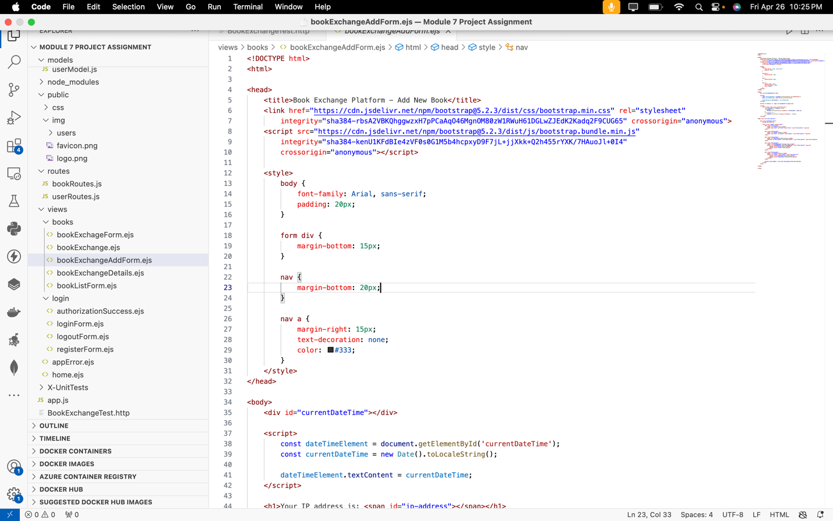

1. **External Dependencies:** This is achieved through the <link> and <script> tags in the <head> section.
2. **Dynamic Content:** JavaScript embedded within the HTML document retrieves and displays the current date and time, as well as the user's IP address, using the Fetch API. This dynamic content is injected into specific elements within the <body> section.
3. **Form Submission:** The <form> element defines a form for adding a new book. It specifies the action attribute as "/books" and the method attribute as "post", indicating that form data will be sent to the "/books" endpoint using the HTTP POST method upon submission.

**bookExchangeDetails.ejs**

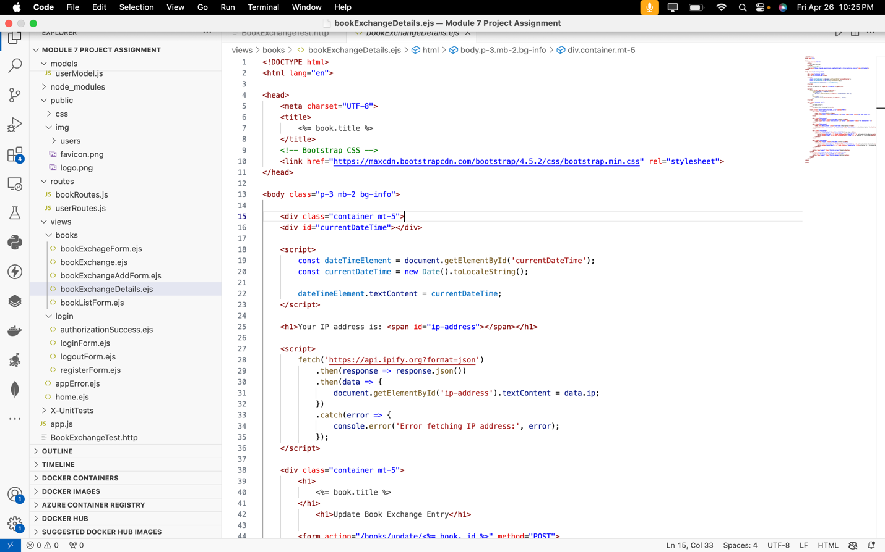

**bookListForm.ejs**

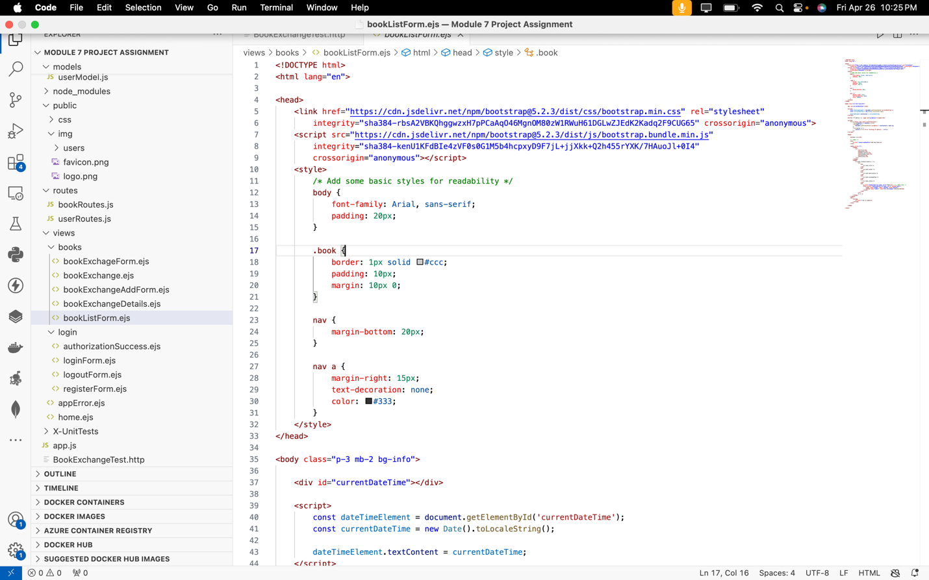

**authorizationSuccess.ejs**

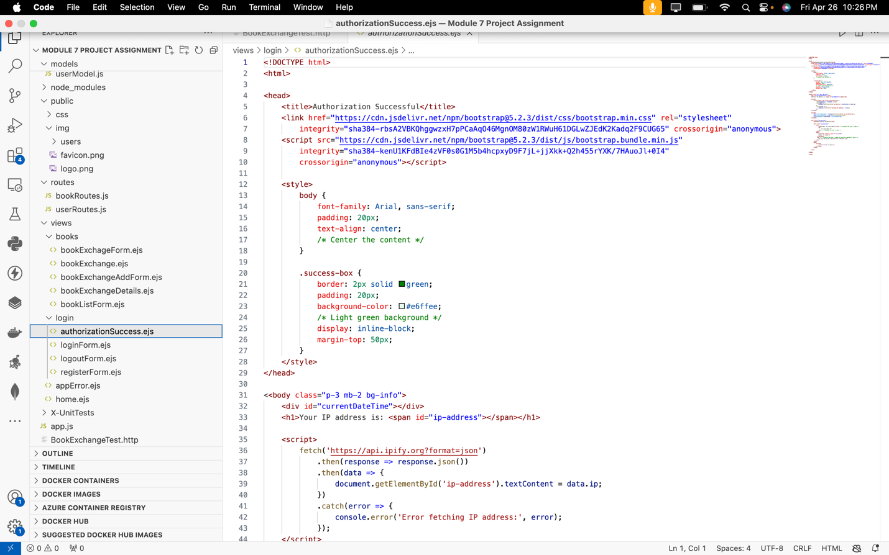

**loginForm.ejs**

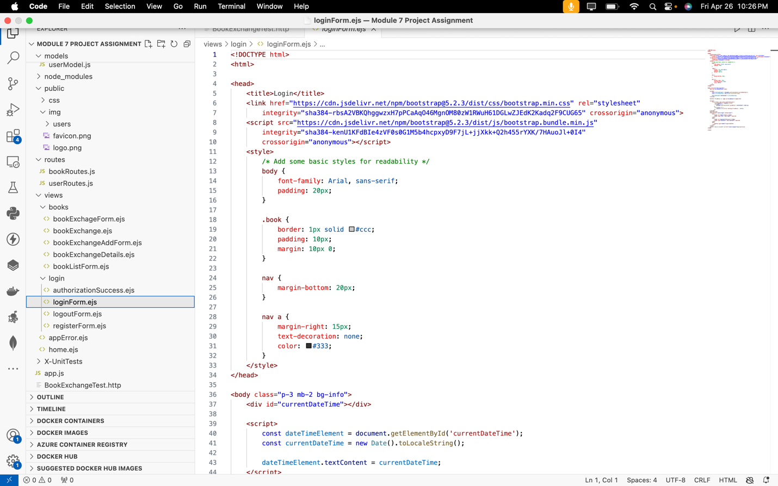

**logoutForm.ejs**

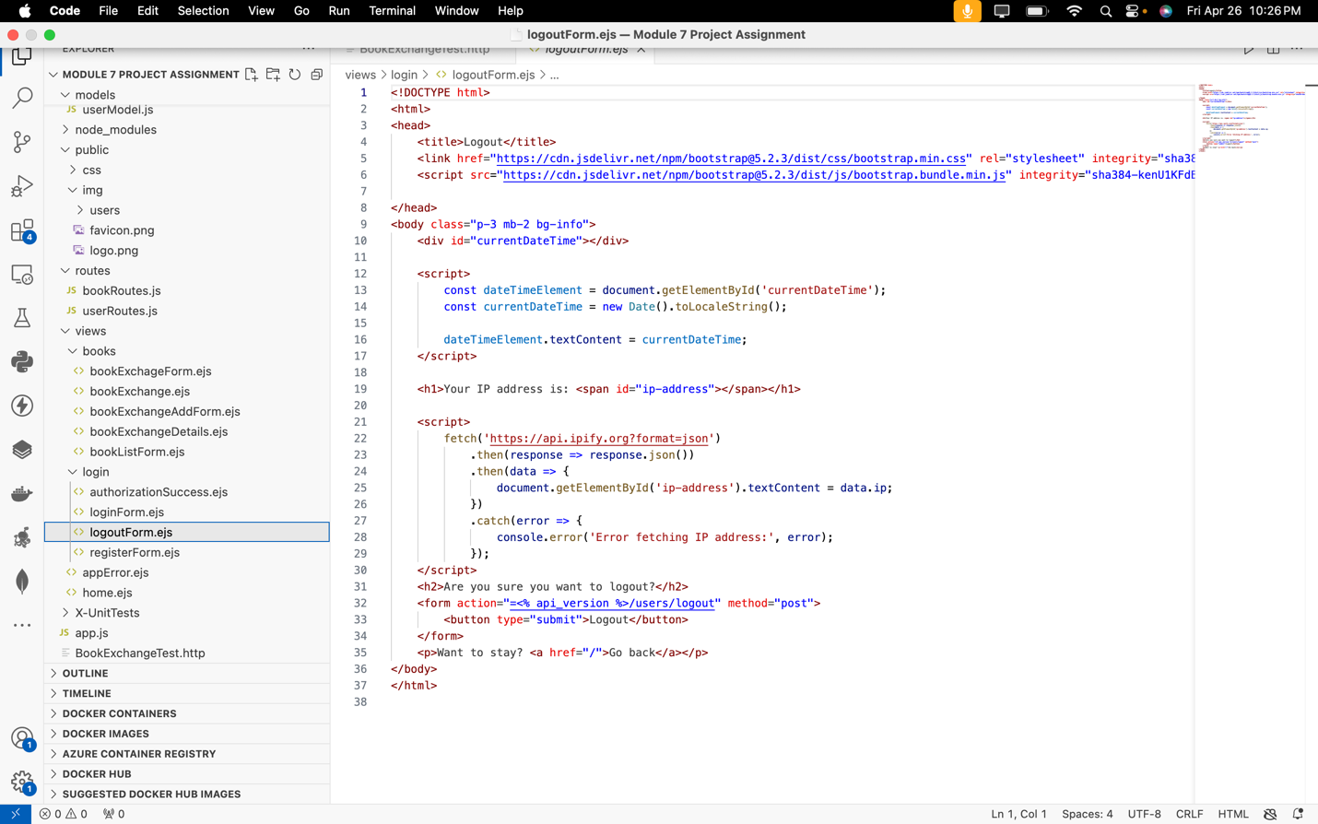

**registerForm.ejs**

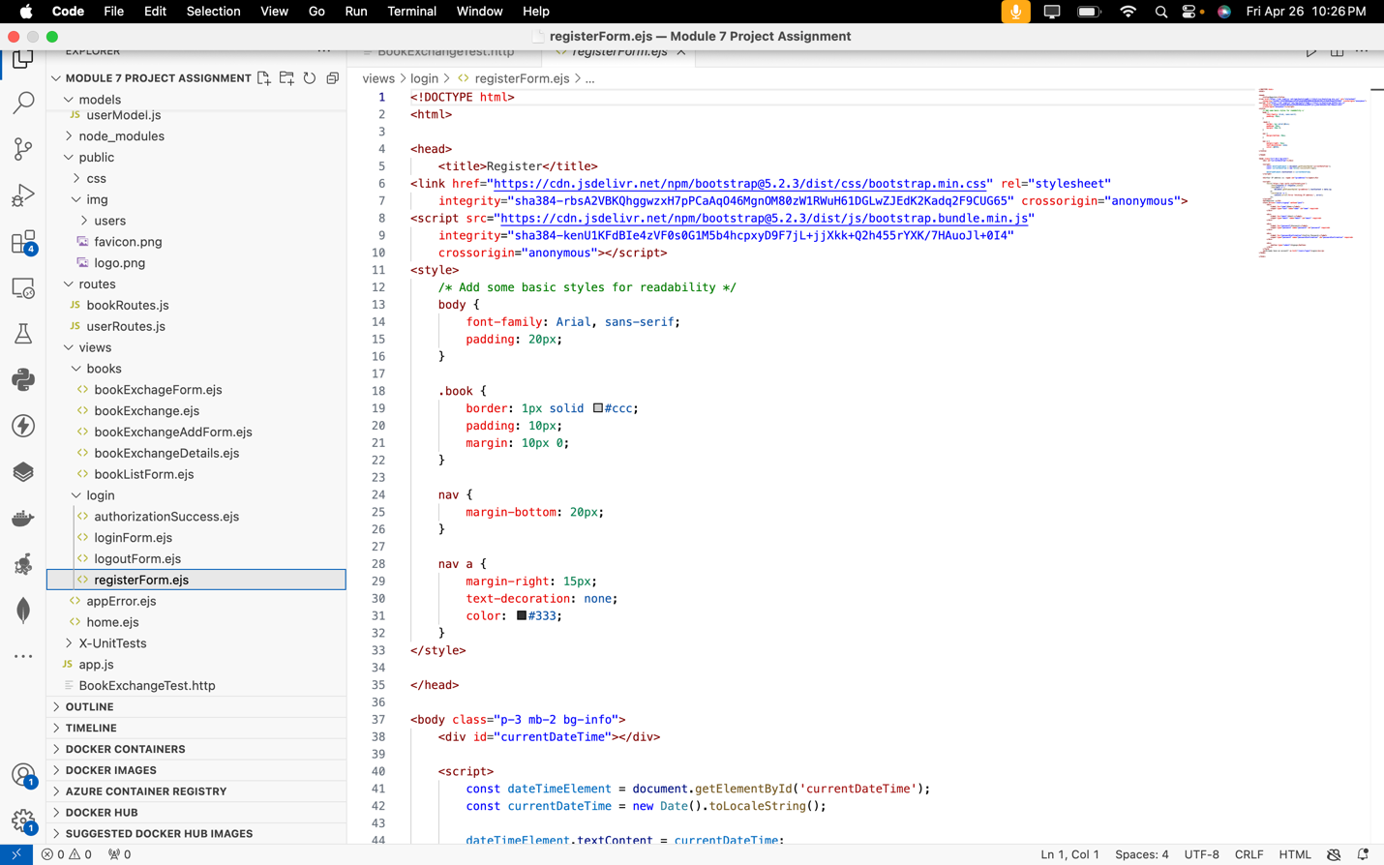

**appError.ejs**

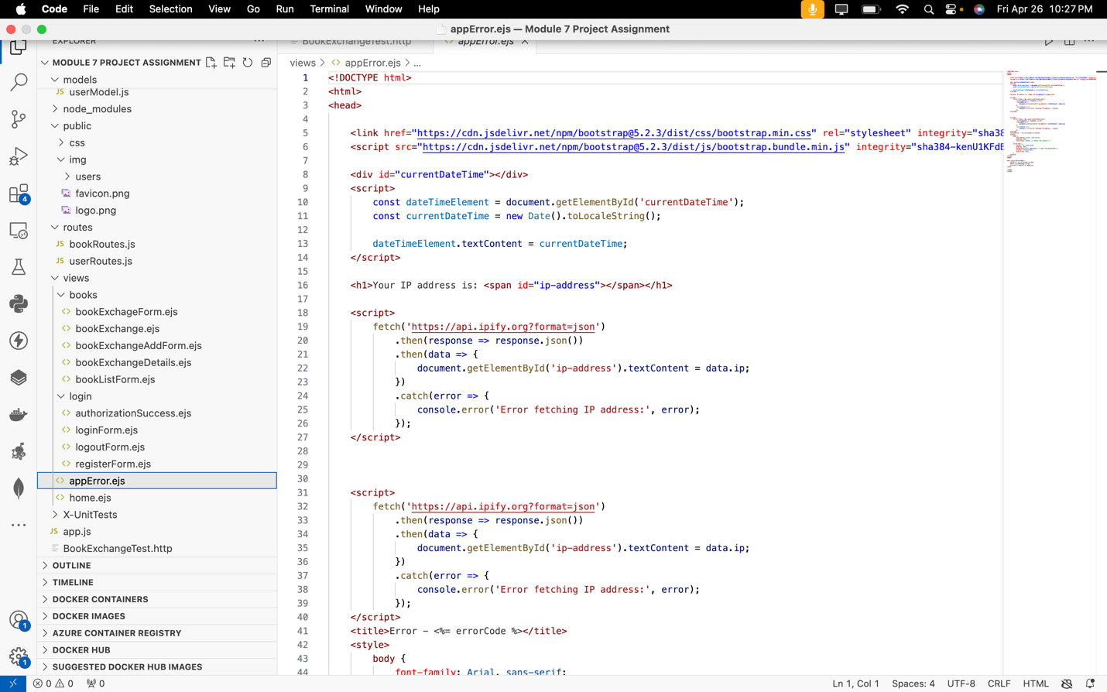

**home.ejs**

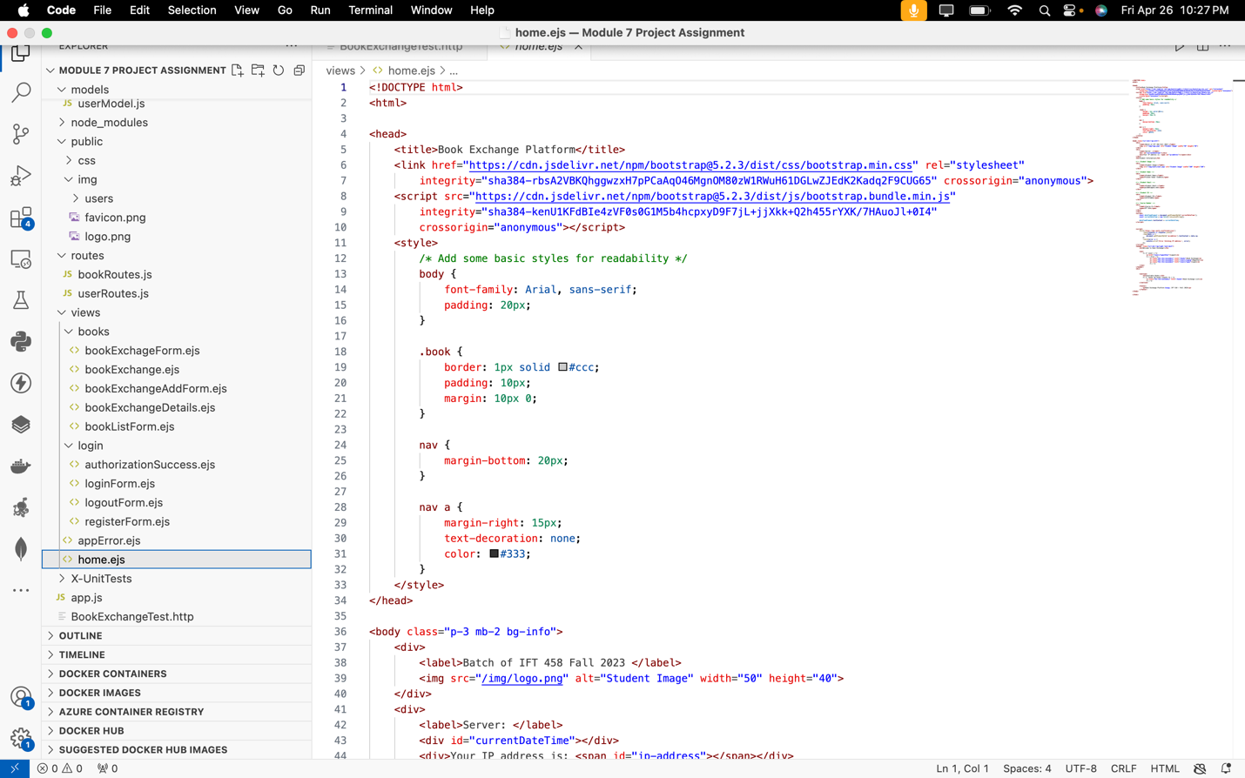

**server.js**

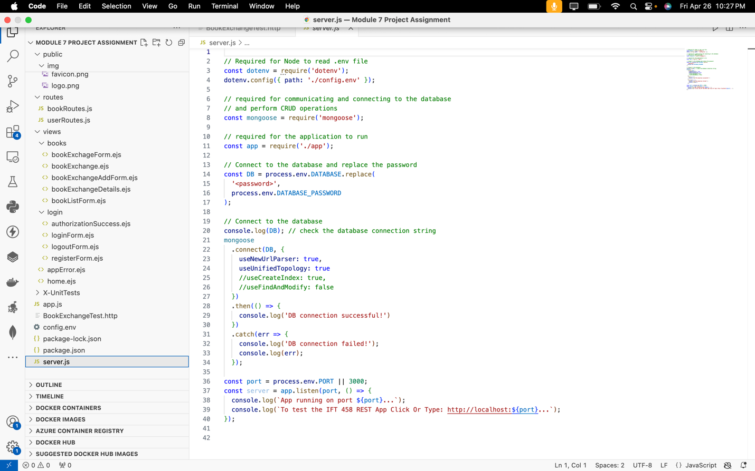

**API Specifications:**

The API specifications detail the endpoints, request methods, and expected formats necessary for communicating with the backend of the application. These specifications follow RESTful principles and encompass functionalities like user authentication, book listing, and exchange.

Specific endpoints include:

* Registering or signing up, accessed via the POST method at <https://localhost:4000/users/signup>
* Logging in, utilizing the POST method at <https://localhost:4000/users/login>
* Accessing protected resources, achieved through the GET method at <https://localhost:4000/books>
* Viewing all available books, accessible via the GET method at <https://localhost:4000/books>
* Adding a book for exchange, done through the POST method at <https://localhost:4000/books/newBookForm>
* Updating or deleting a book exchange, facilitated via the POST method at <http://localhost:4000/books/edit/65e565c188ab31ac49627500>

**Module 7 Activity 1: Generating SSL Certificate and Configuring HTTPS Server in Node.js on Windows**

**Screenshot 1**: Showing the OpenSSL installed confirmation.

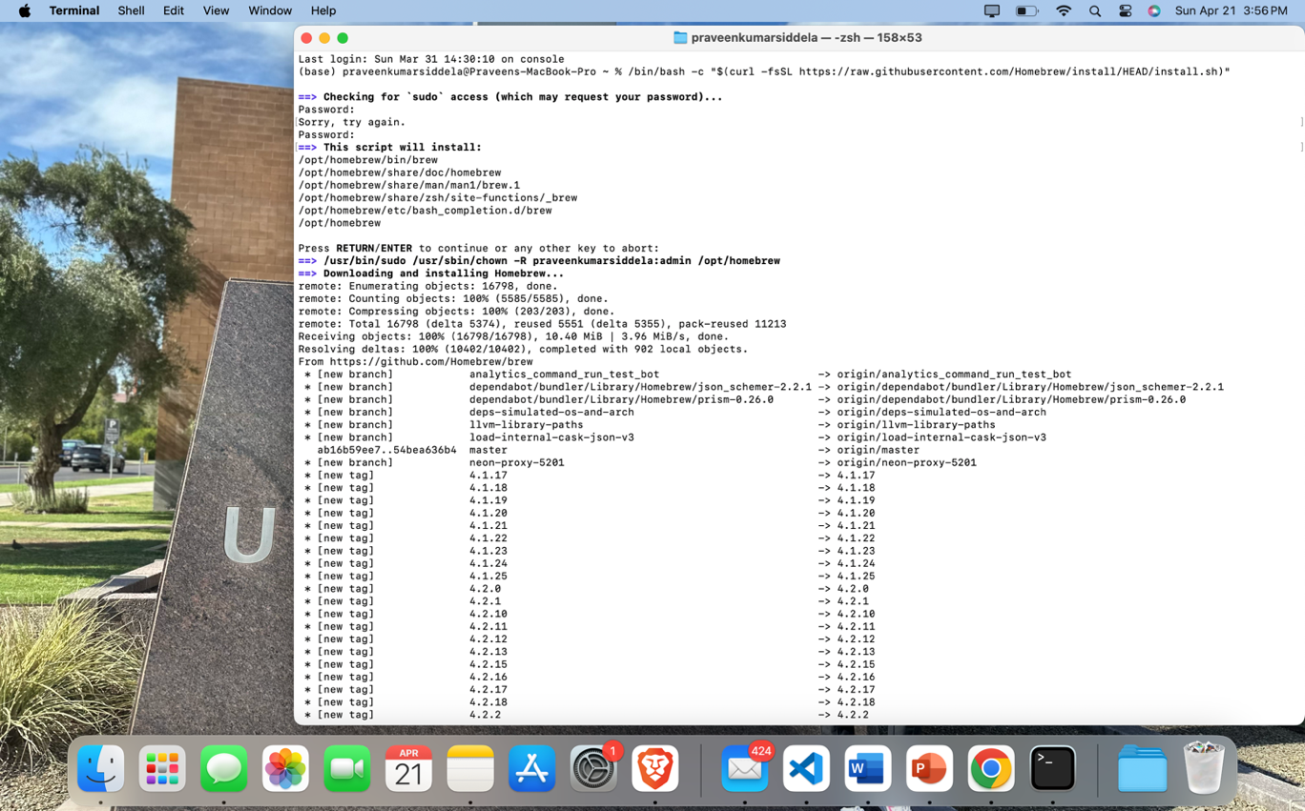

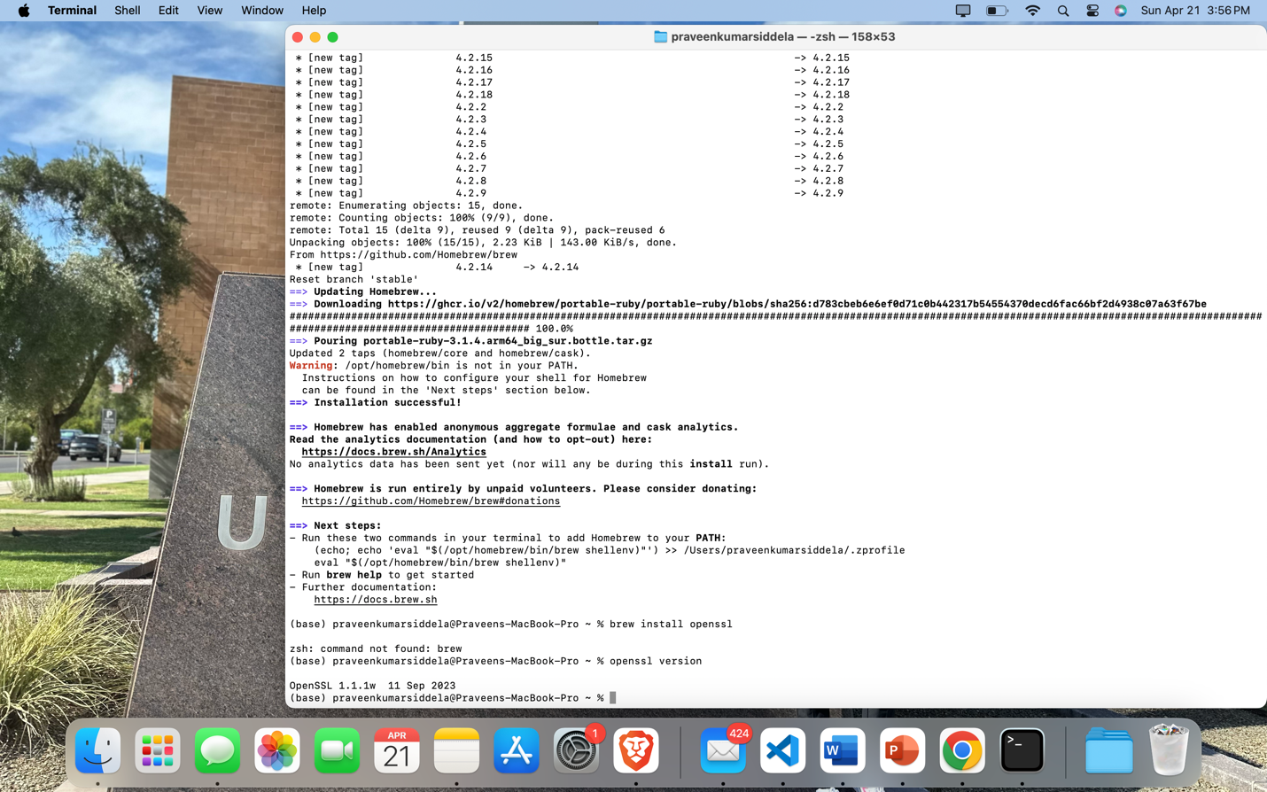**Screenshot 2**: Showing Command Prompt after generating server.key.

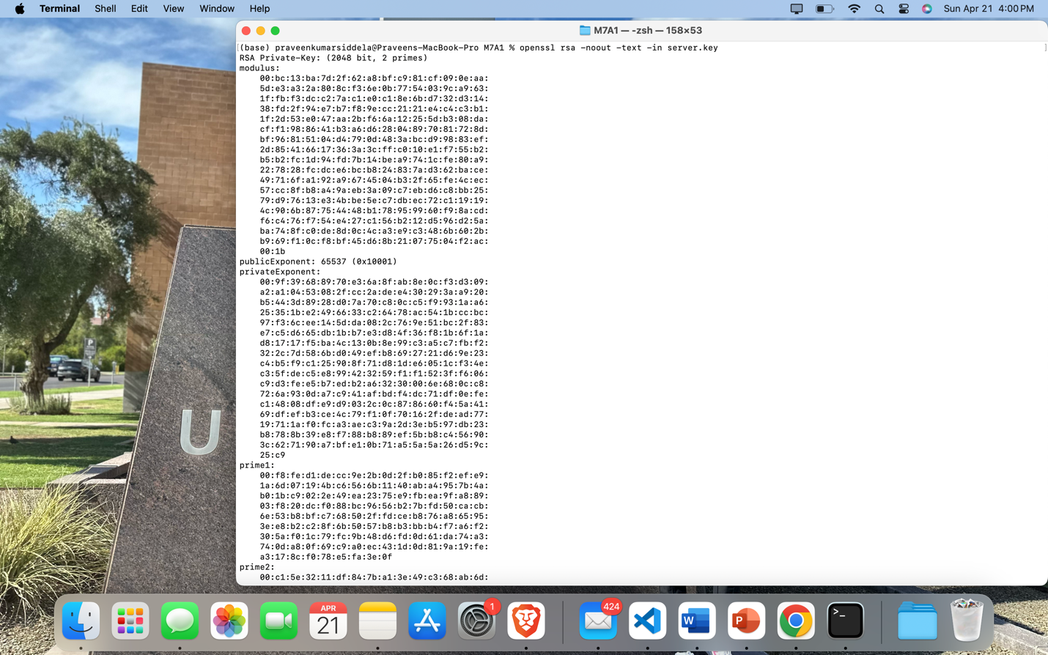

**Screenshot 3**: Showing execution of command to generate server.cer

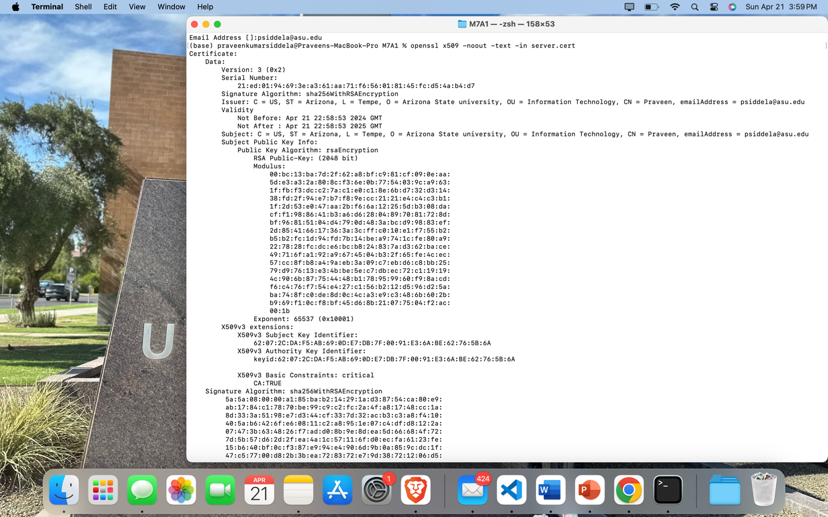**Screenshot 4**: Showing filled-in certificate information prompts.

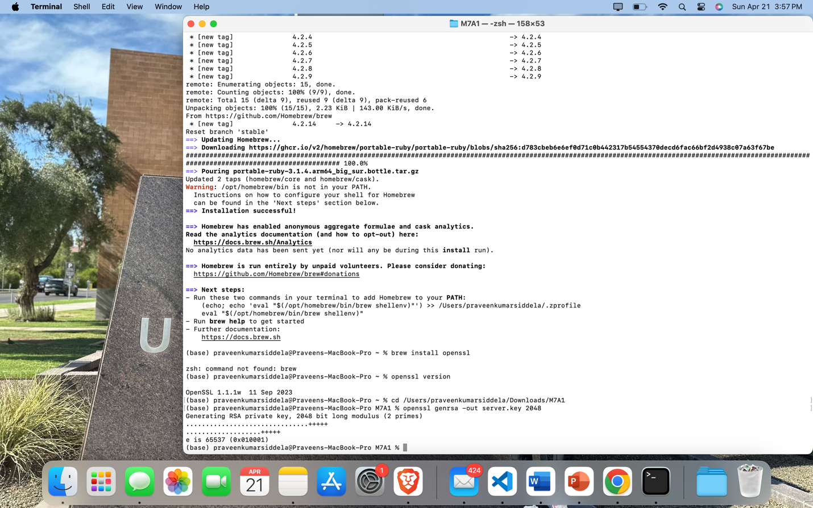



**Screenshot 5**: Showing output of verification commands in Command Prompt.





**Screenshot 6**: Of the project folder with server.key and server.cert files.

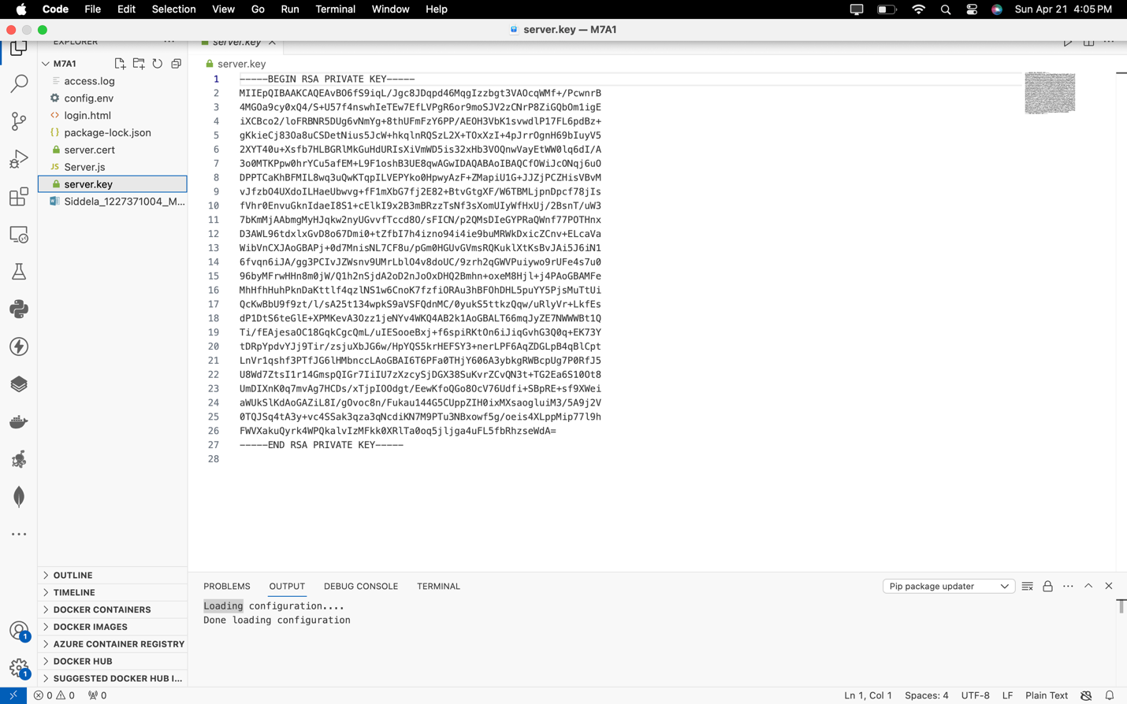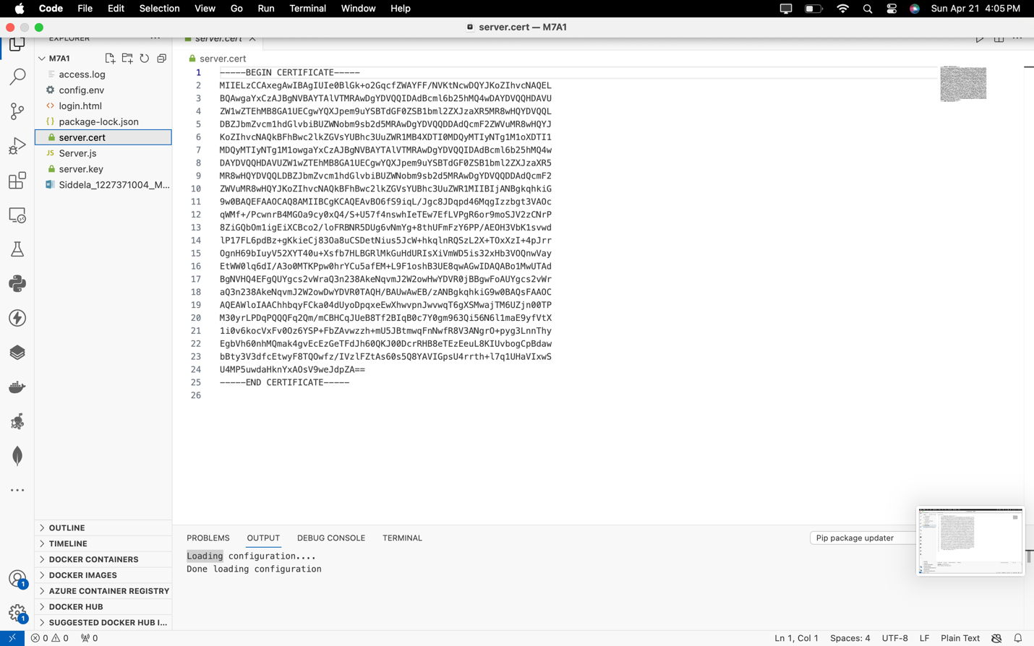

**Screenshot 7**: Showing the modified Server.js file in your IDE.

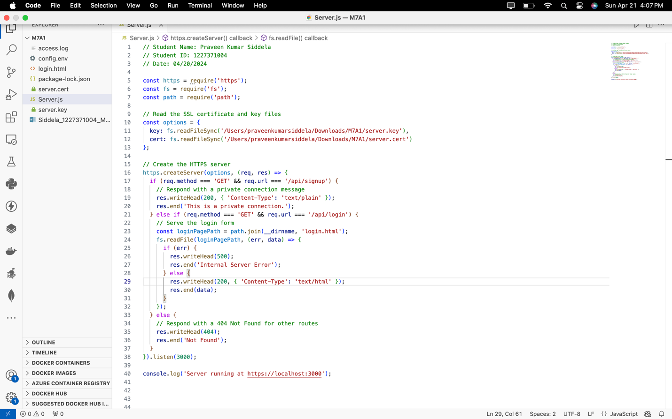**Screenshot 8**: Showing the terminal with the running Node.js server.

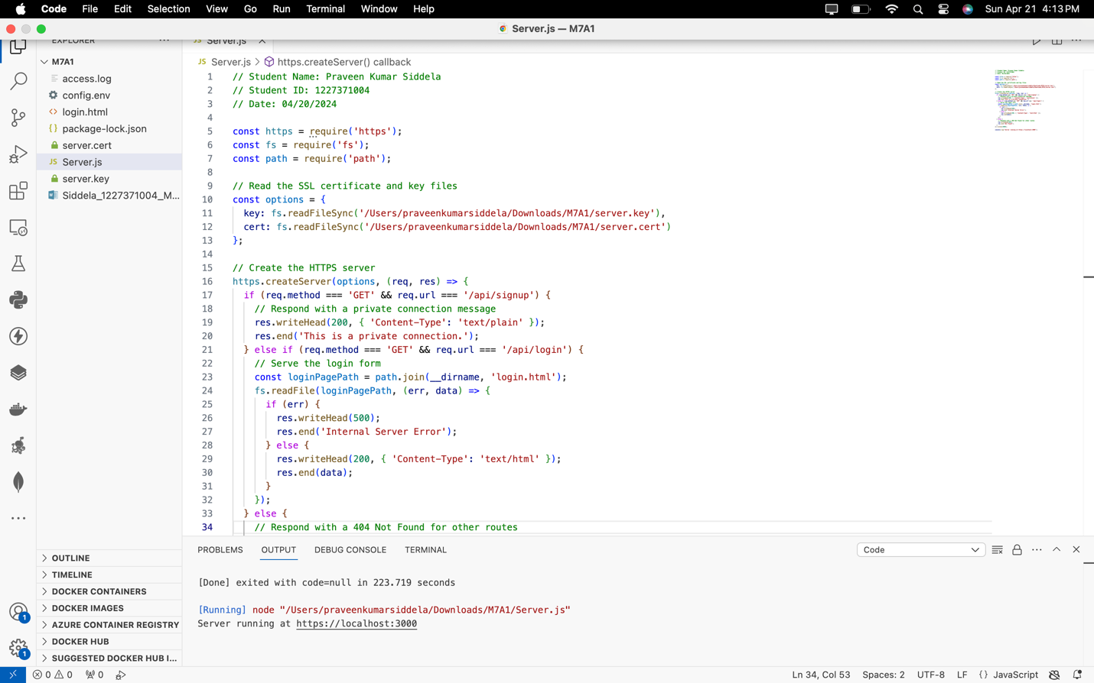

**Screenshot 9**: Showing the browser view when accessing the HTTPS server.

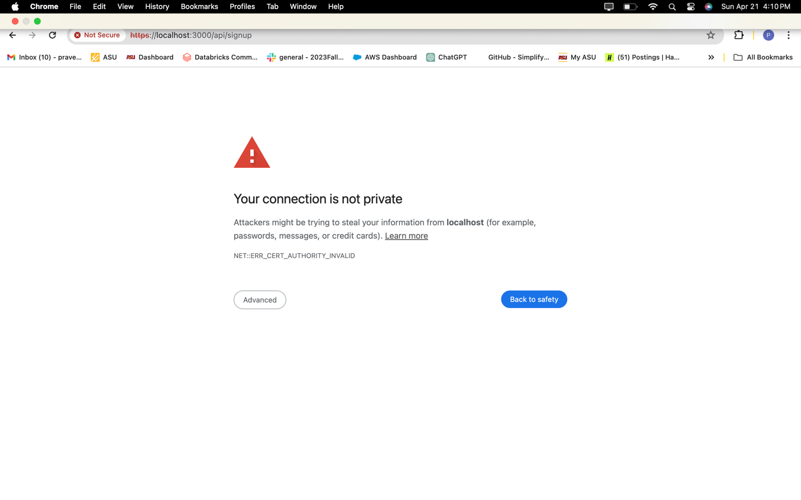**Screenshot 10**: Showing the browser's security warning.

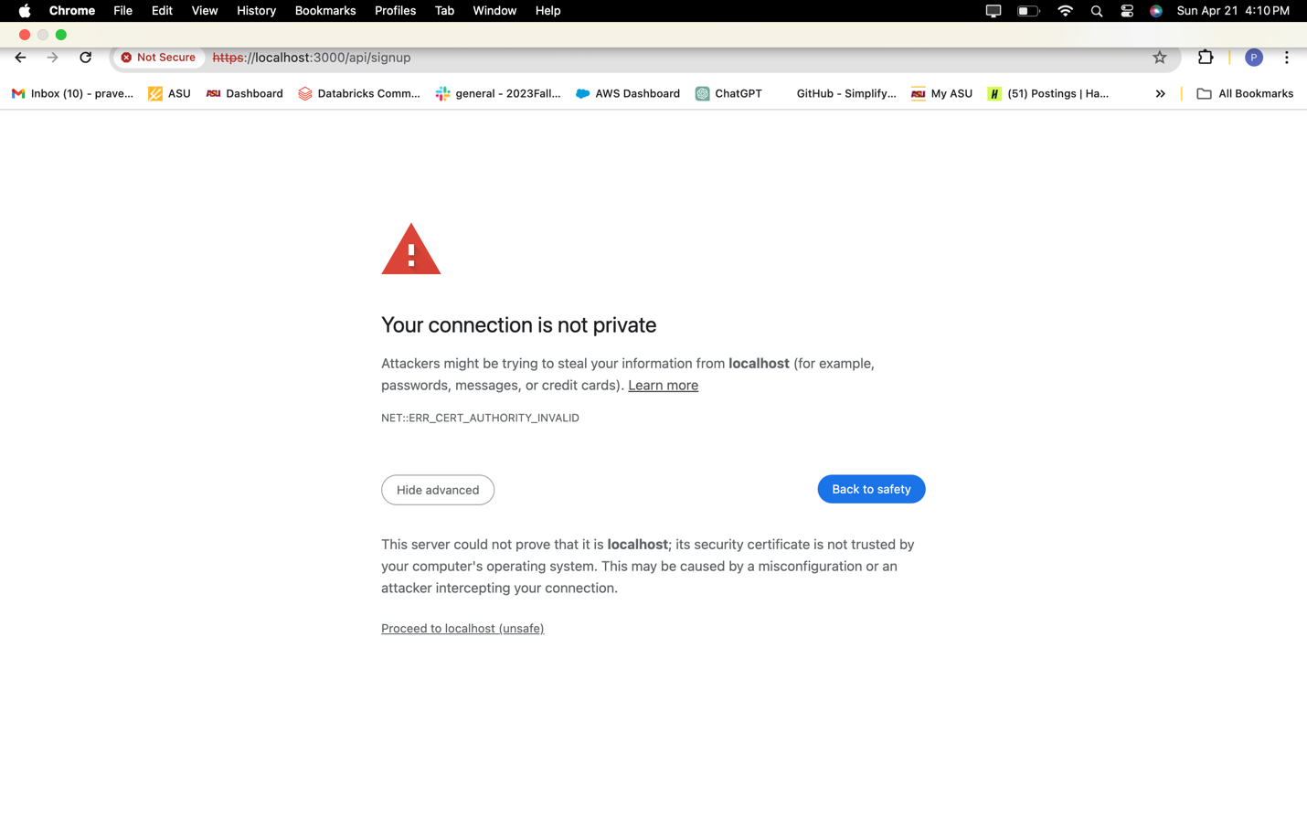

**Screenshot 11**: Displaying the URL change after accepting the security warning.

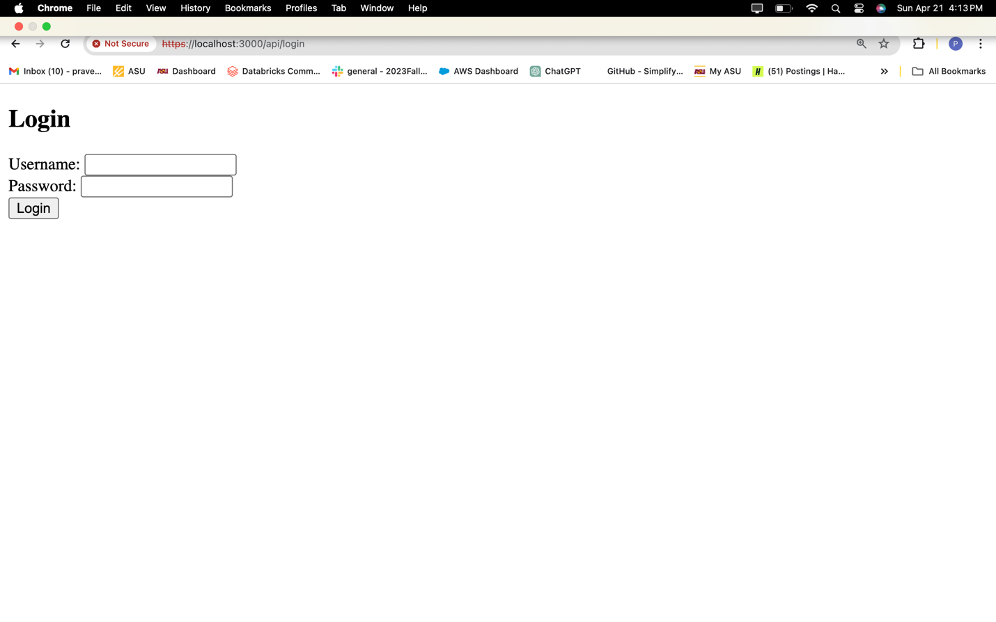

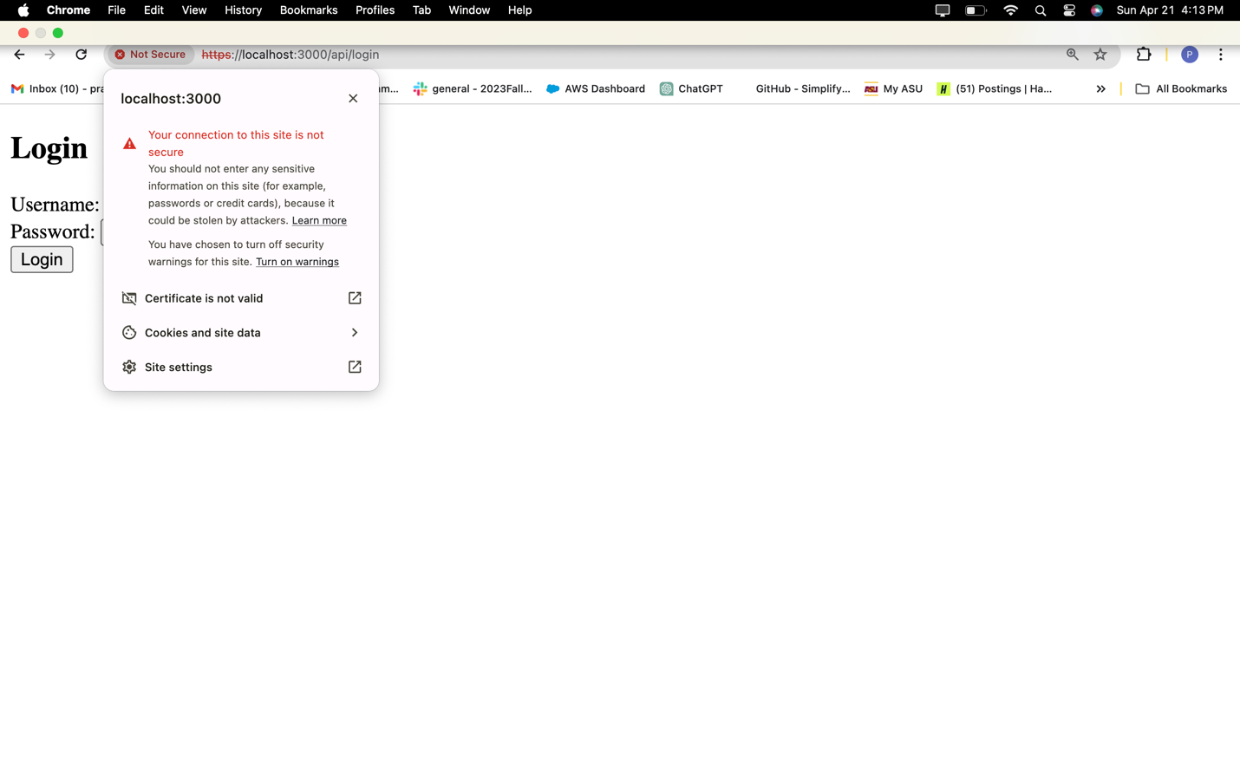

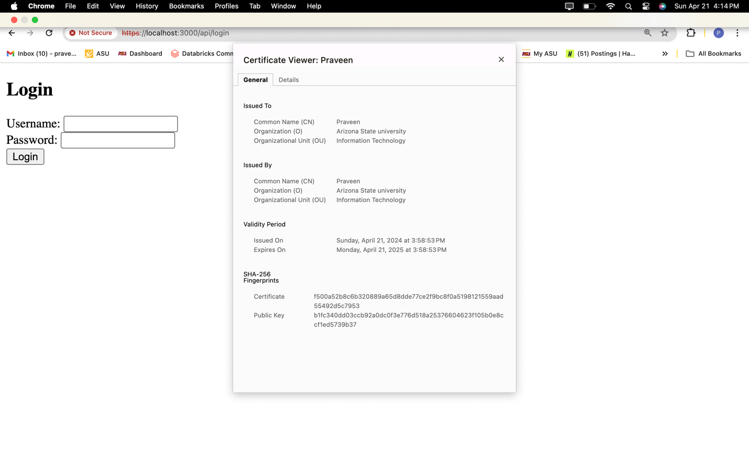

**Module 7 Activity 2: Implementing HTTP Status Codes and Error Handling in Node.js**

**Screenshot 1**: Of the initialized project structure in your IDE.

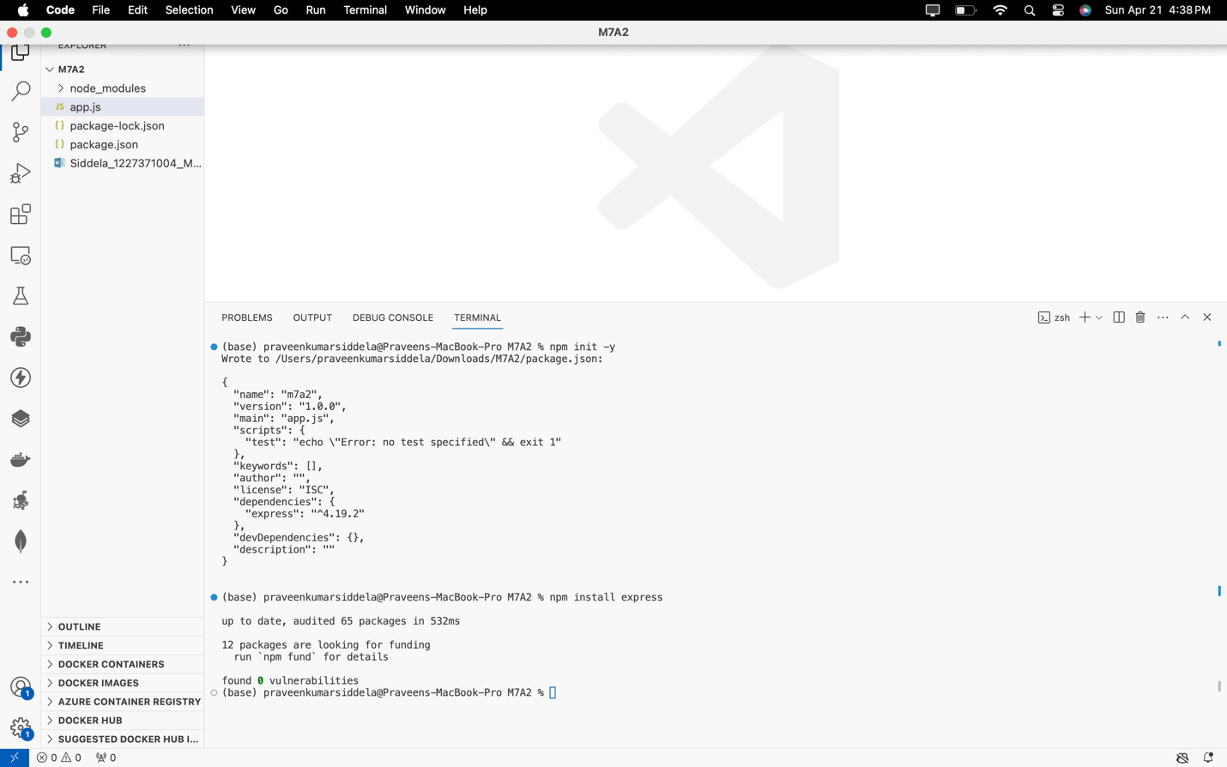

**Screenshot 2**: Showing the app.js file implemented routes for different HTTP status codes.

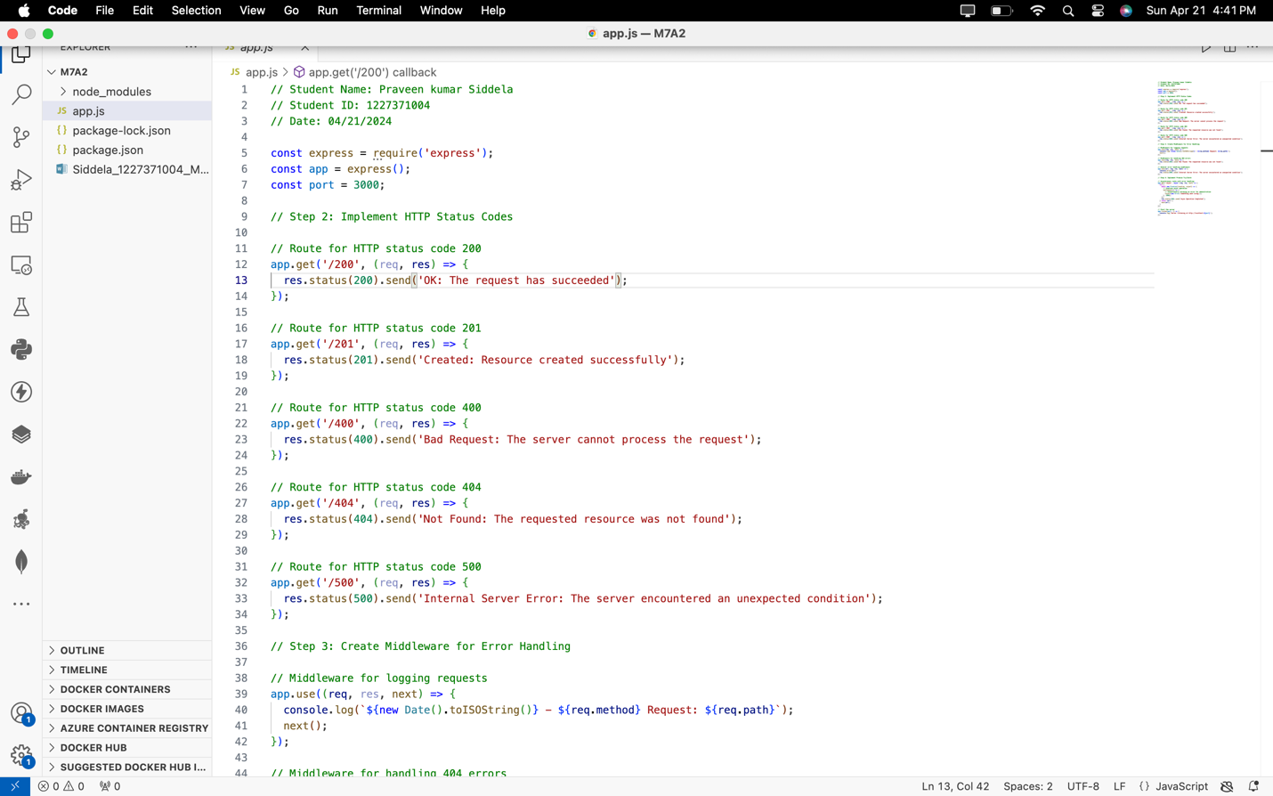

**Screenshot 3**: Displaying the implemented middleware in app.js for request logging and error handling.

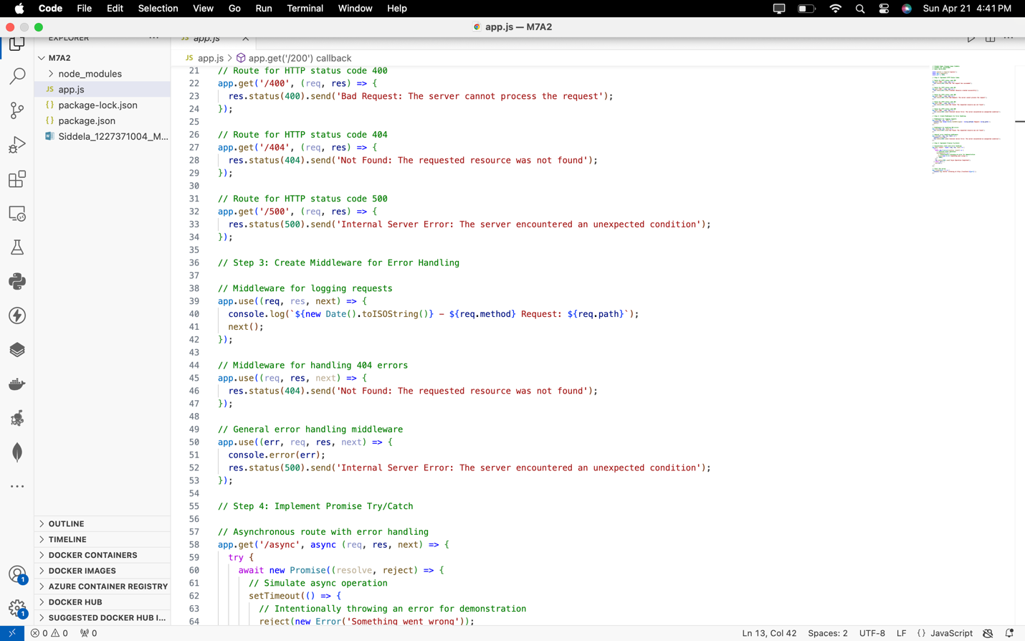

**Screenshot 4**: Of the asynchronous route with try/catch in app.js.

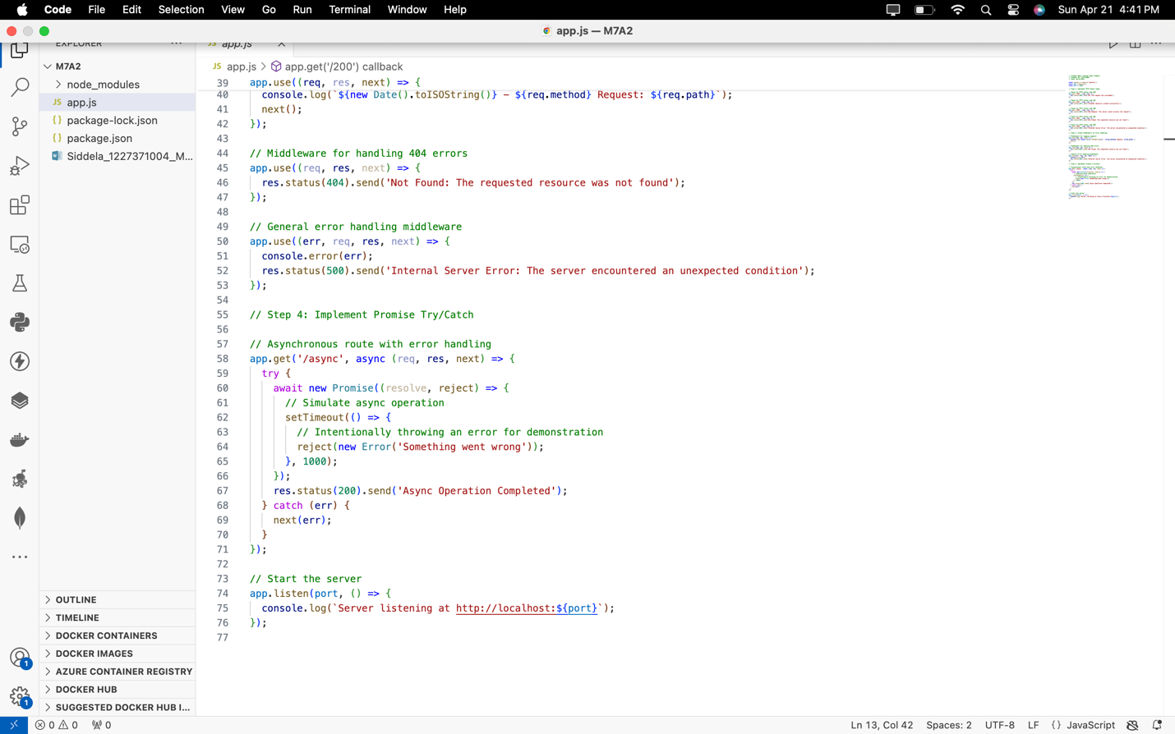

**Screenshot 5**: Showing the running server in the terminal.

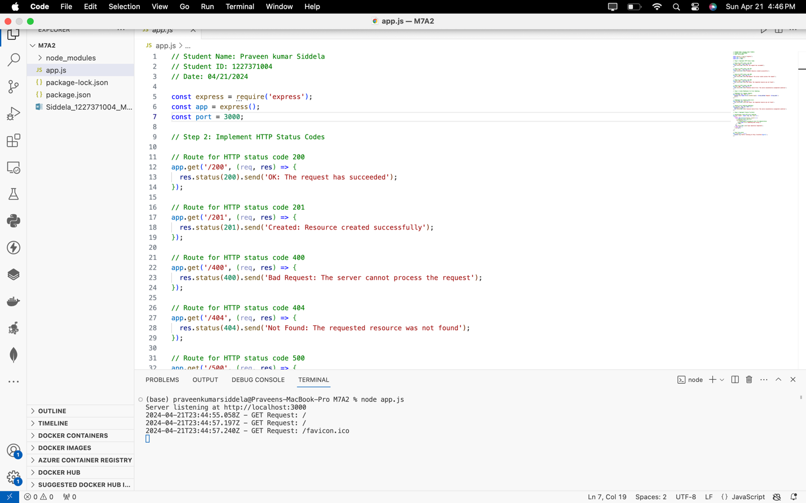

**Screenshot 6**: Displaying responses from the server for different routes in Postman or a web browser

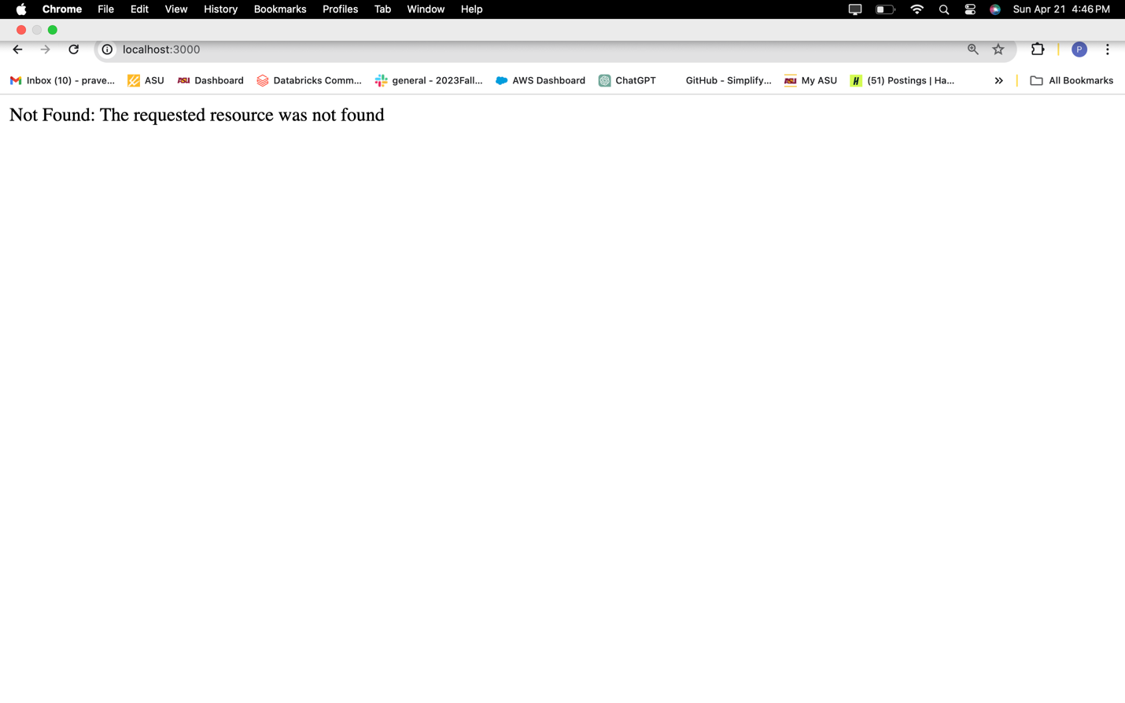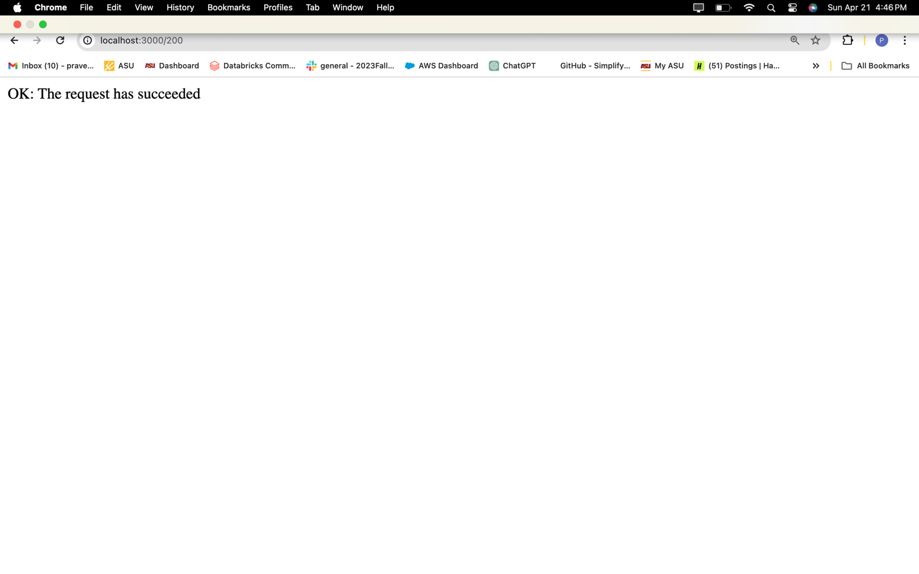

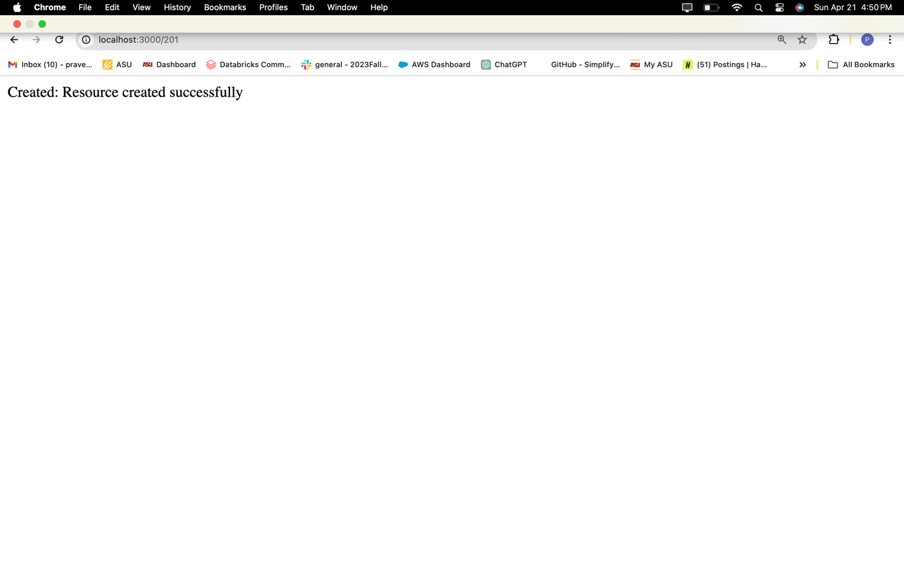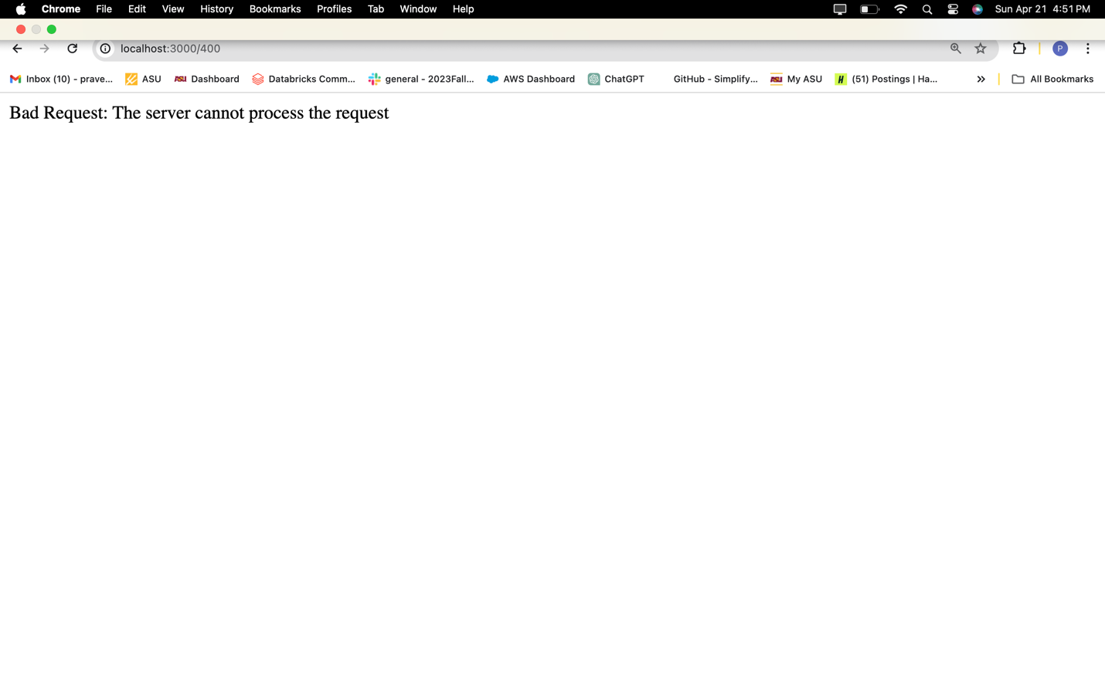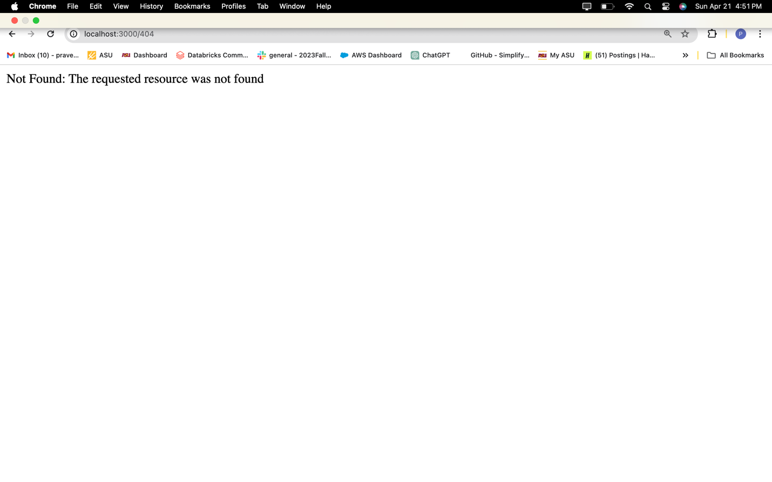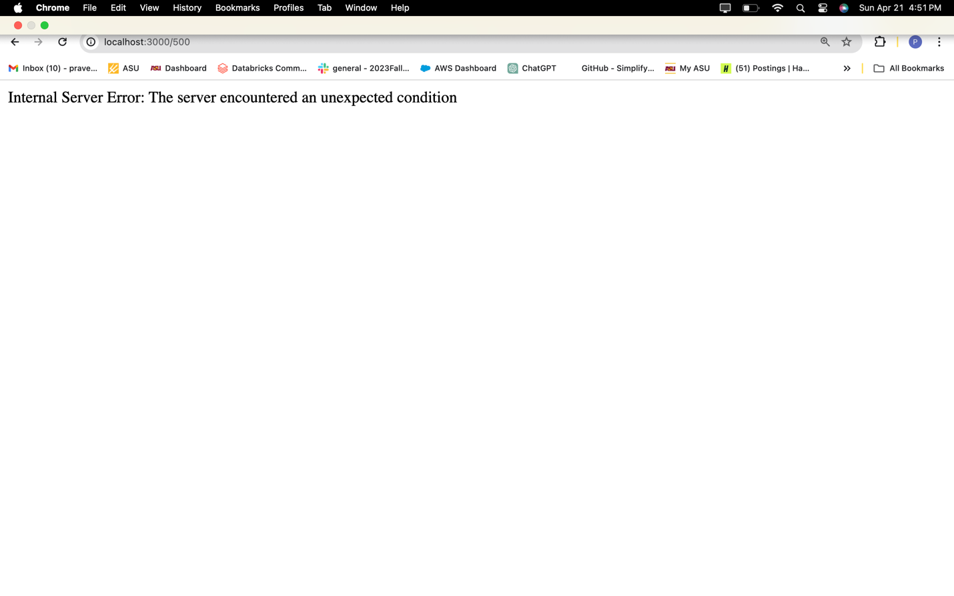

**Module 7 Lab 1: Develop Secure Middleware & Backend Database for a Book Exchange Application**

**Screenshot 1**: Of the terminal showing successful installation of dependencies.

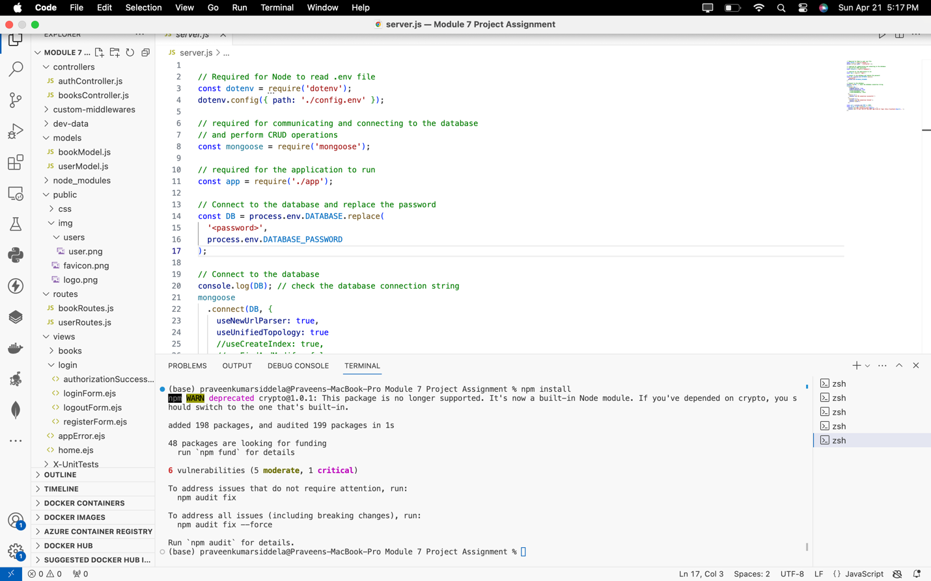

**Screenshot 2**: Of the project directory structure showcasing MVC organization.

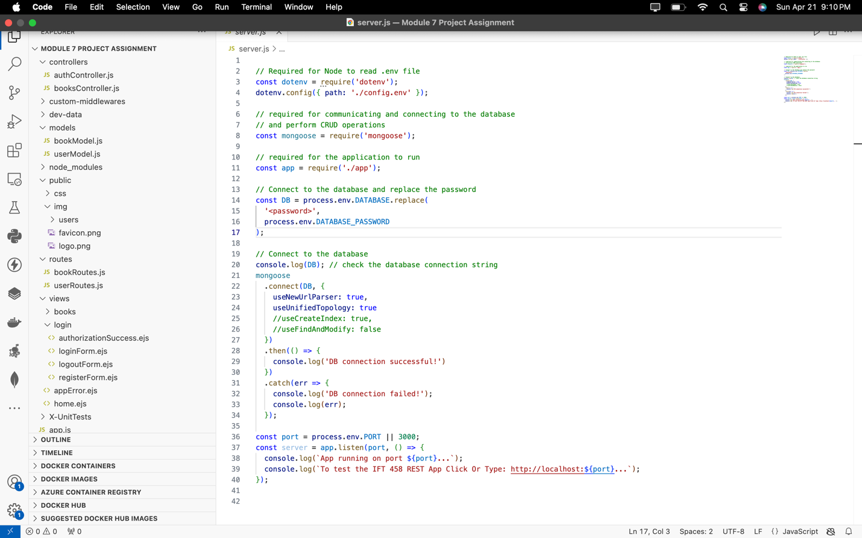

**Screenshot 3**: Of the BookModel.js file with a brief explanation.

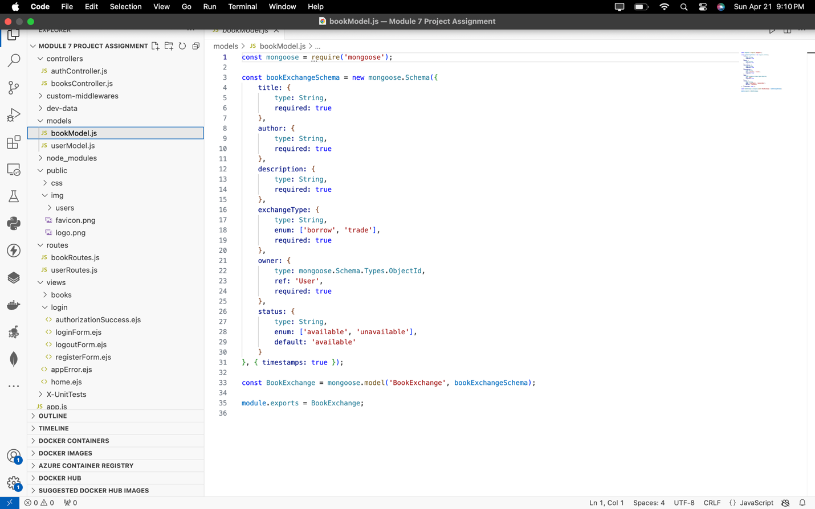

The **bookModel.js** file defines the book data structure for the application using Mongoose. It specifies properties like title, author, description, exchangeType, owner, and status, with precise data types and constraints. Enums ensure consistency for exchangeType and status. The owner field references the 'User' model. Default values and timestamps are included. The schema becomes a Mongoose model named 'BookExchange' for easy MongoDB interaction, exported for application-wide use.

**Screenshot 4**: Of the bookController.js with the implemented logic.

The **bookController.js** file handles book-related actions in the app. It includes functions for adding, retrieving, updating, and deleting books. Error handling ensures appropriate status codes and messages. Functions like addBook and updateBookForm handle user input, while createBook, getBooks, getBookById, updateBookById, and deleteBook interact with the database. Status codes like 400, 404, and 500 are used for various scenarios, ensuring smooth operation of book-related functionalities.

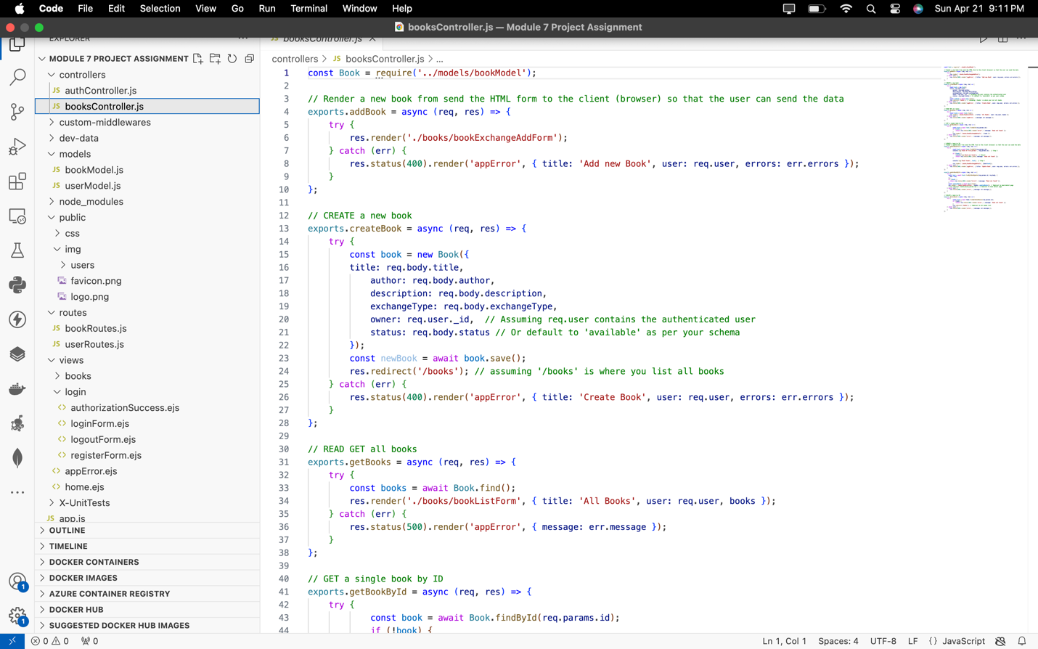

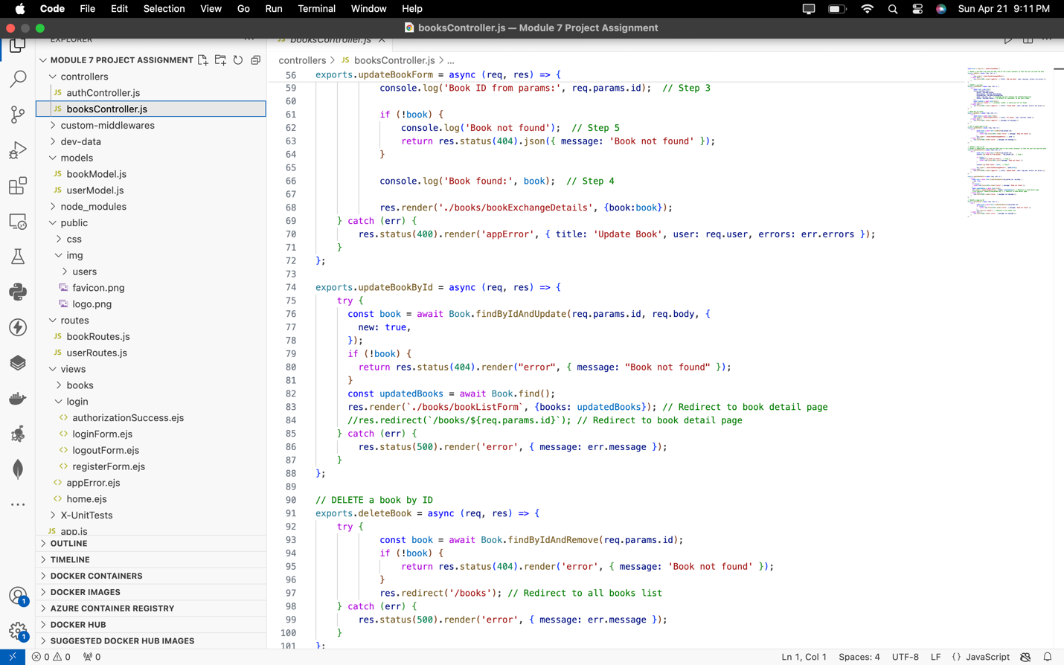

**Screenshot 5**: Of the bookRoutes.js file with defined routes.

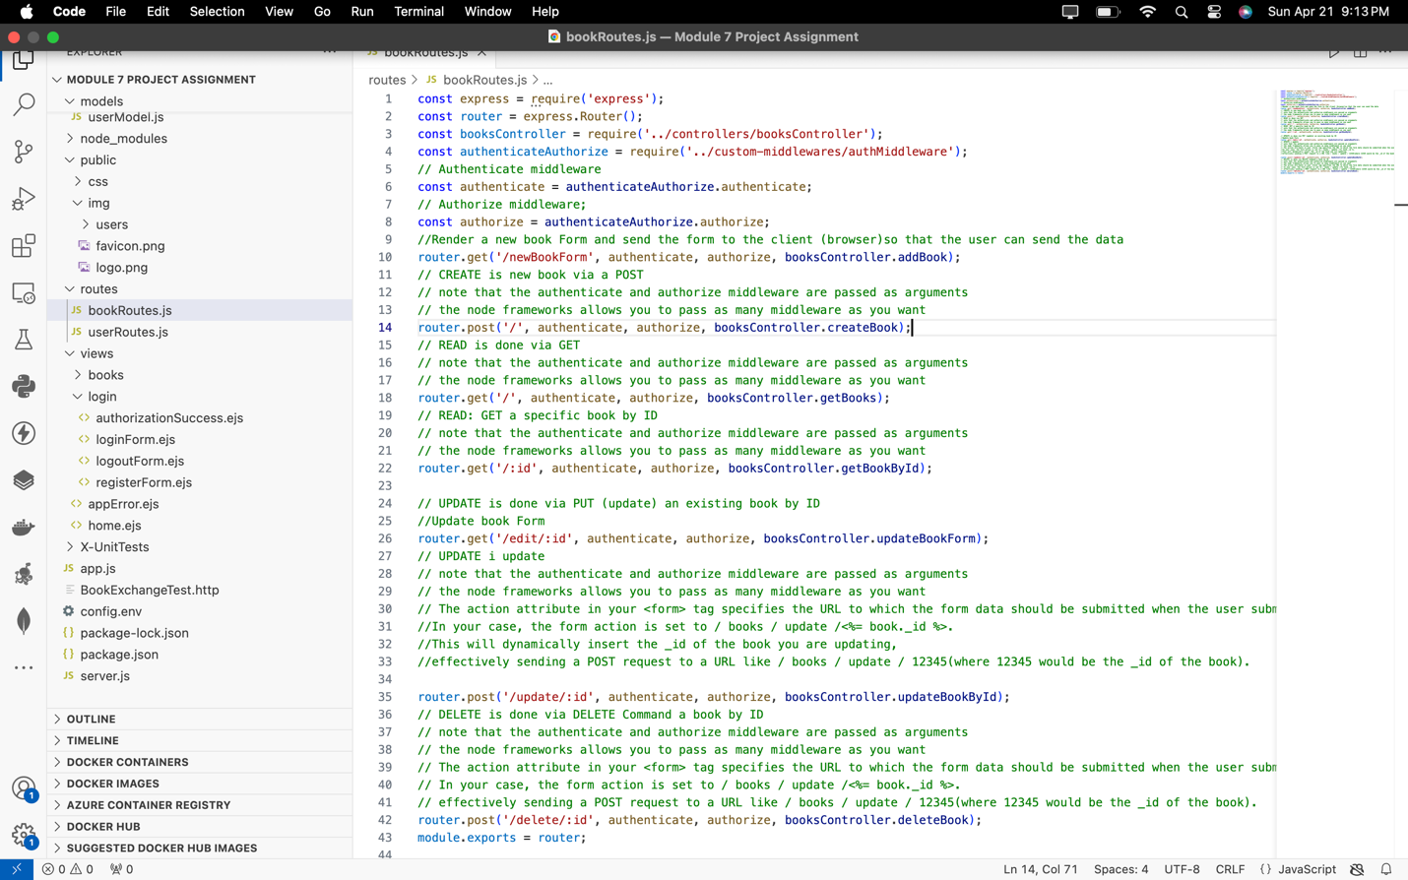

**Screenshot 6**: Of updated view files (*.ejs) and changes made.

The **bookExchangeForm.ejs** page is a web form for adding new books to a book exchange platform. It contains standard HTML structure with metadata and external resources like Bootstrap CSS and JavaScript files. The body section dynamically displays date, time, and user IP. When logged in, it shows a welcome message and links to dashboard and logout; otherwise, it provides signup/login buttons. The main section houses a form for entering book details and submitting them to **/books/add**. The footer includes copyright information. Overall, it serves as a user-friendly interface for adding books to the platform.

Top of Form

Bottom of Form

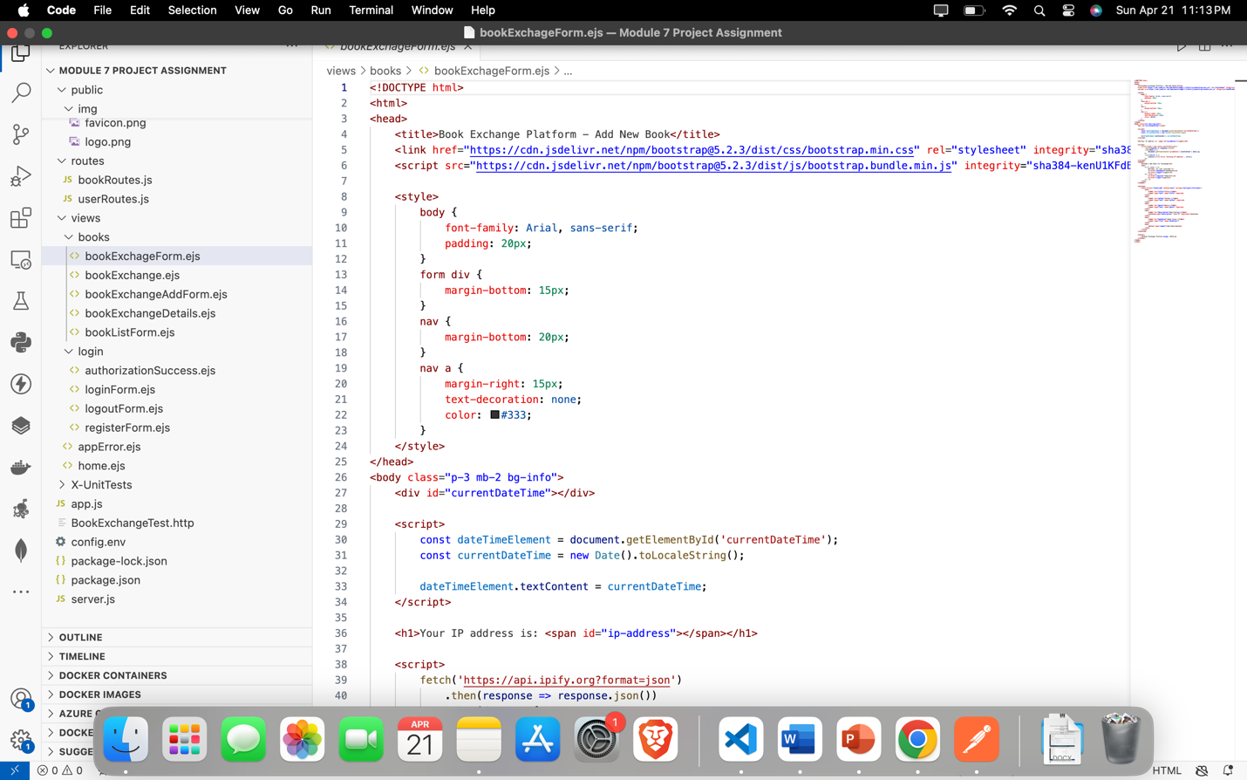

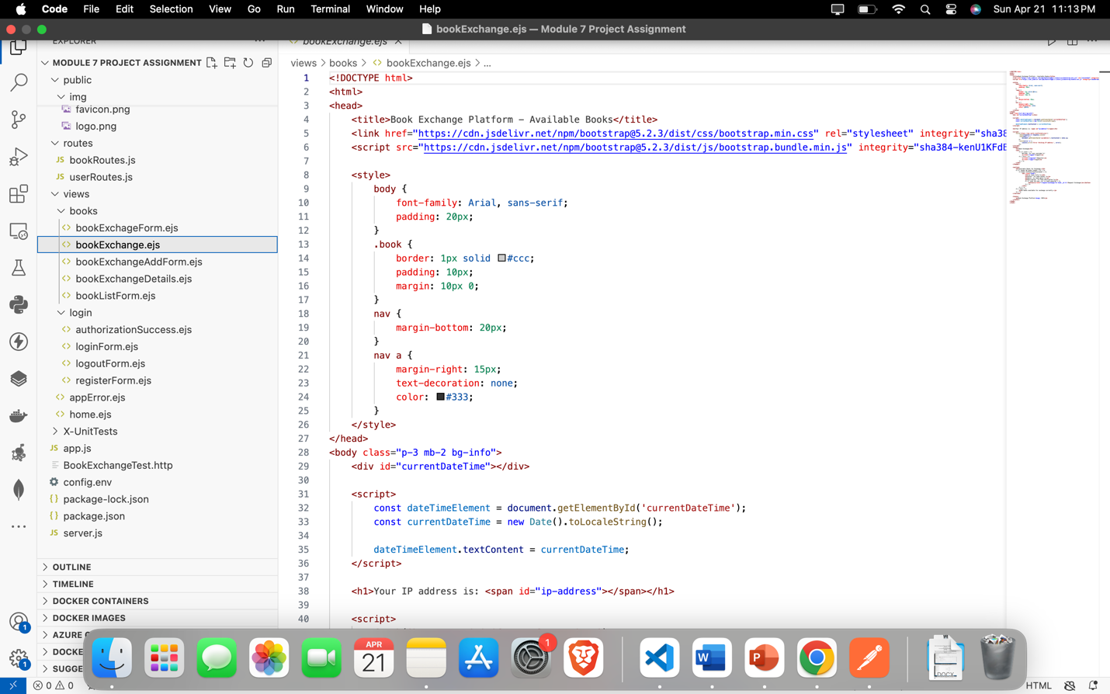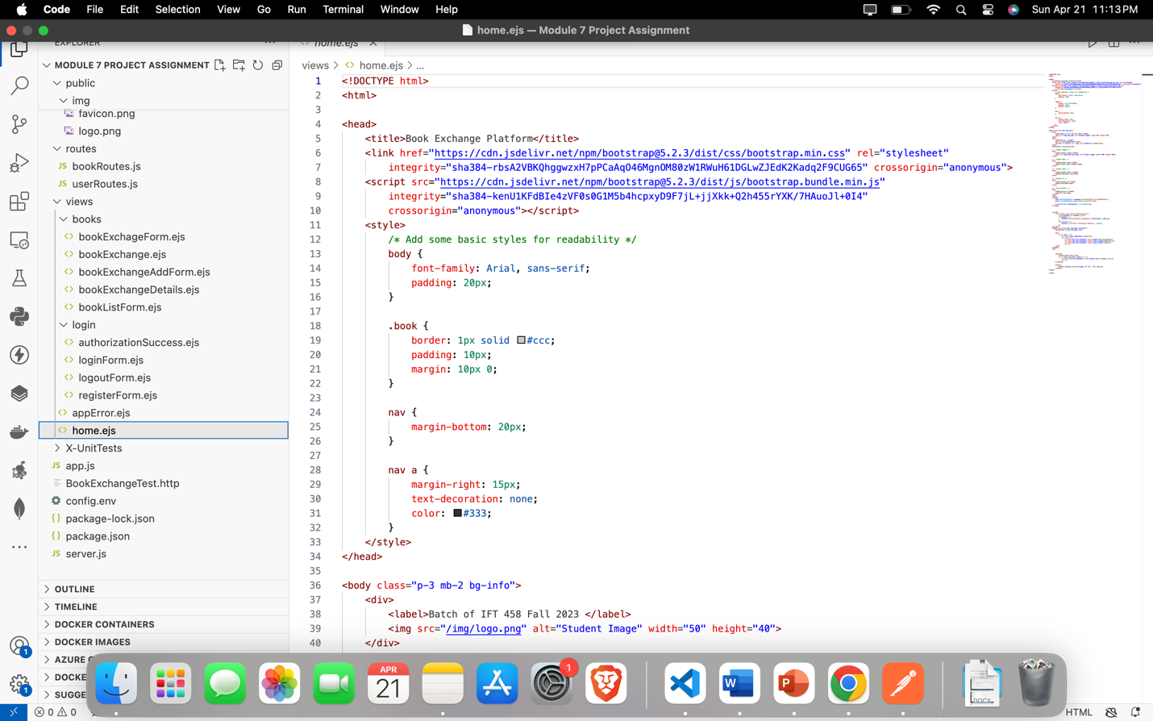

**Screenshot 7**: Of the home page as displayed in the browser.

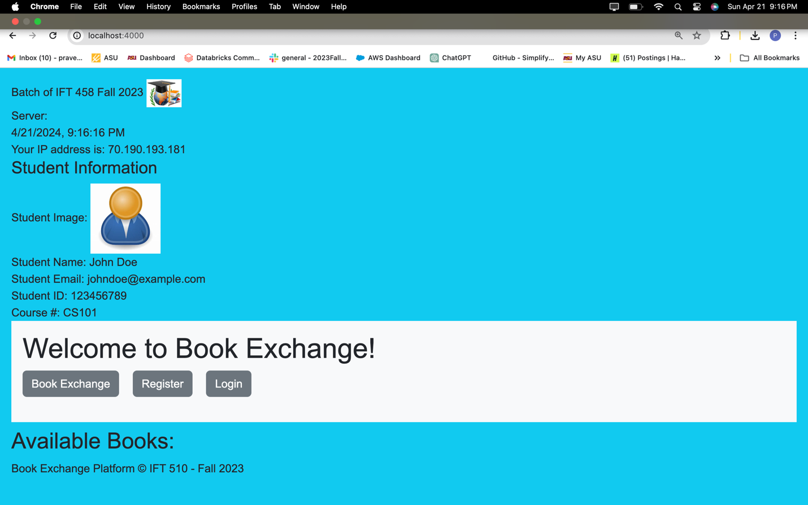

**Screenshot 8**: Of all personalized user interface pages.

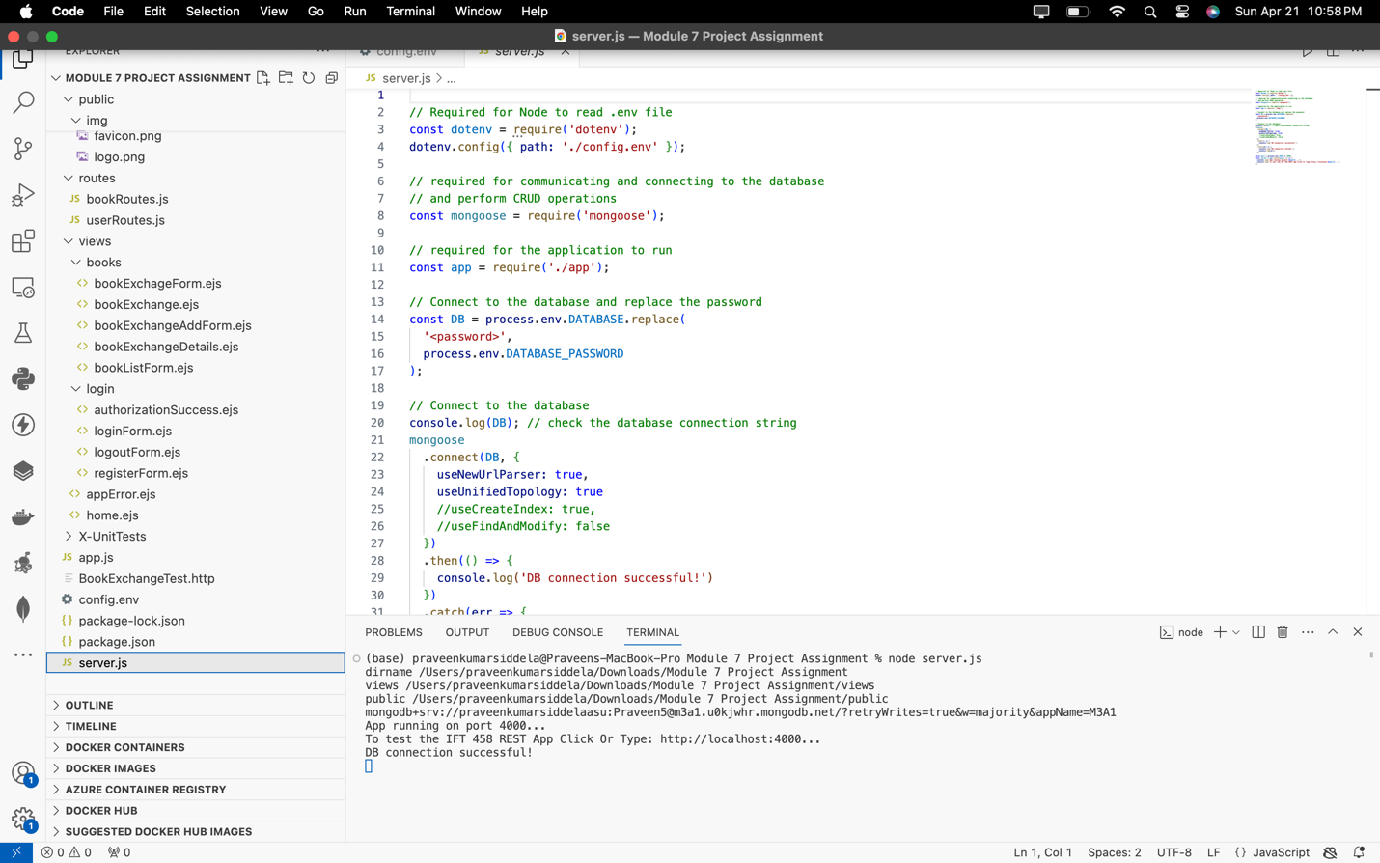**Home Page:**

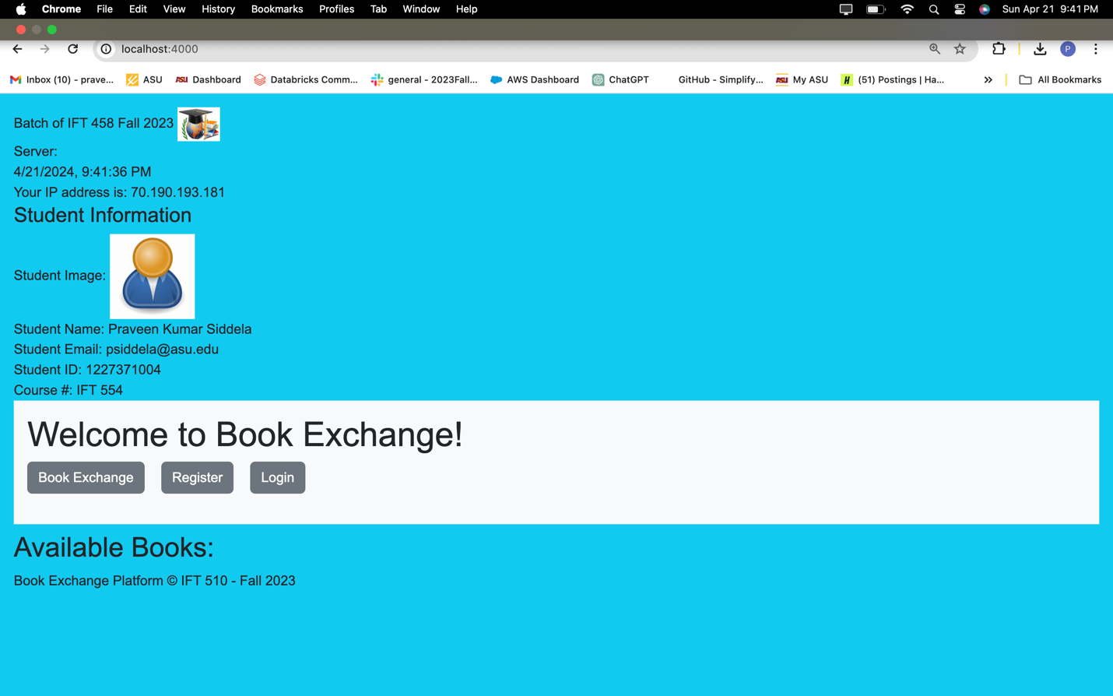

**Signup:**

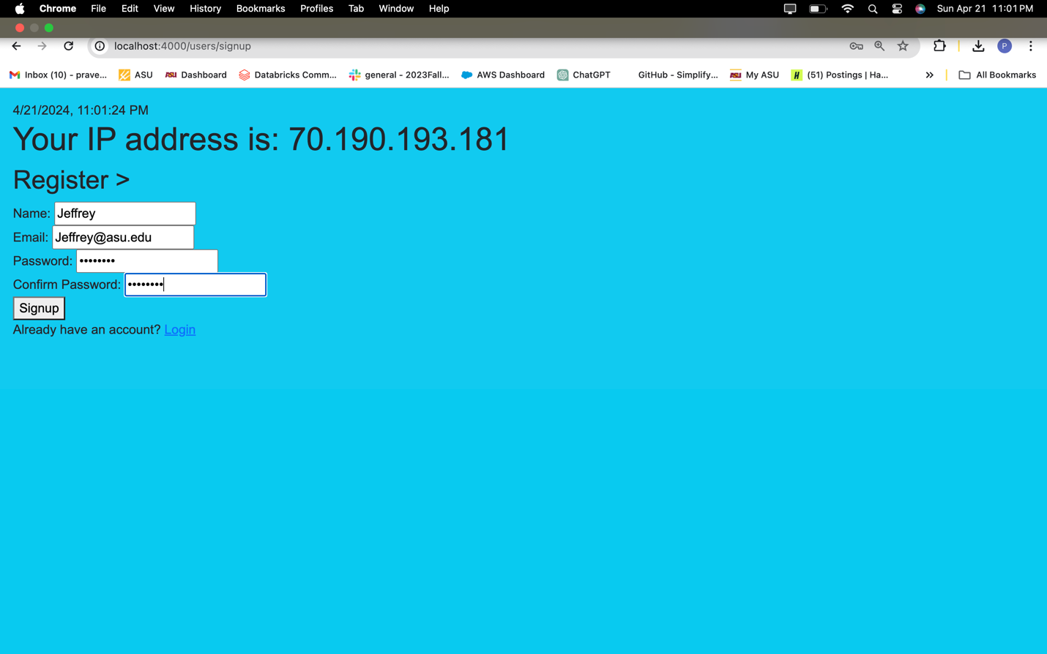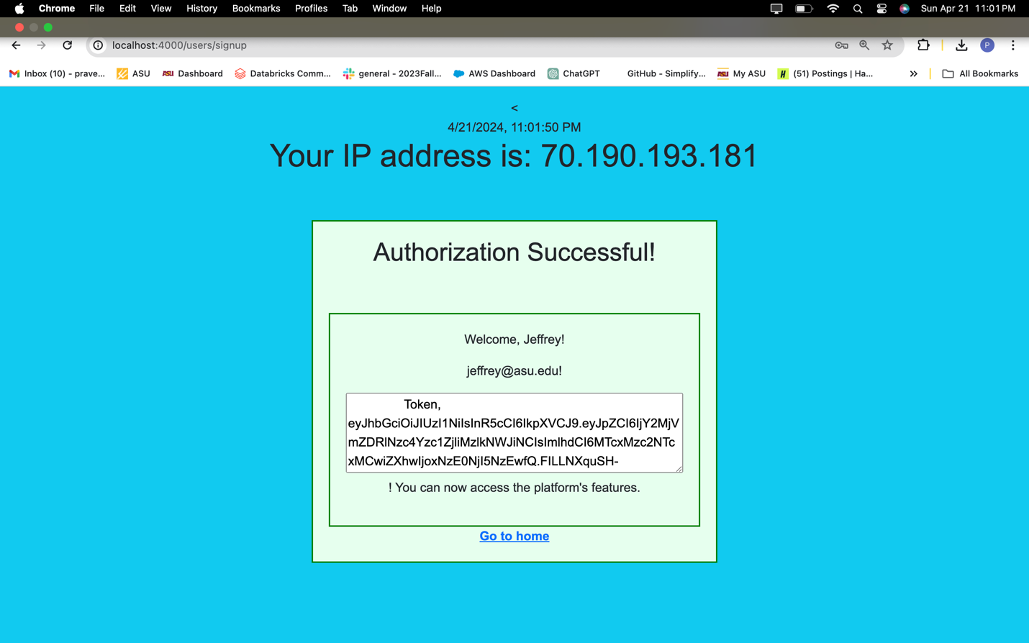

**Login Page:**

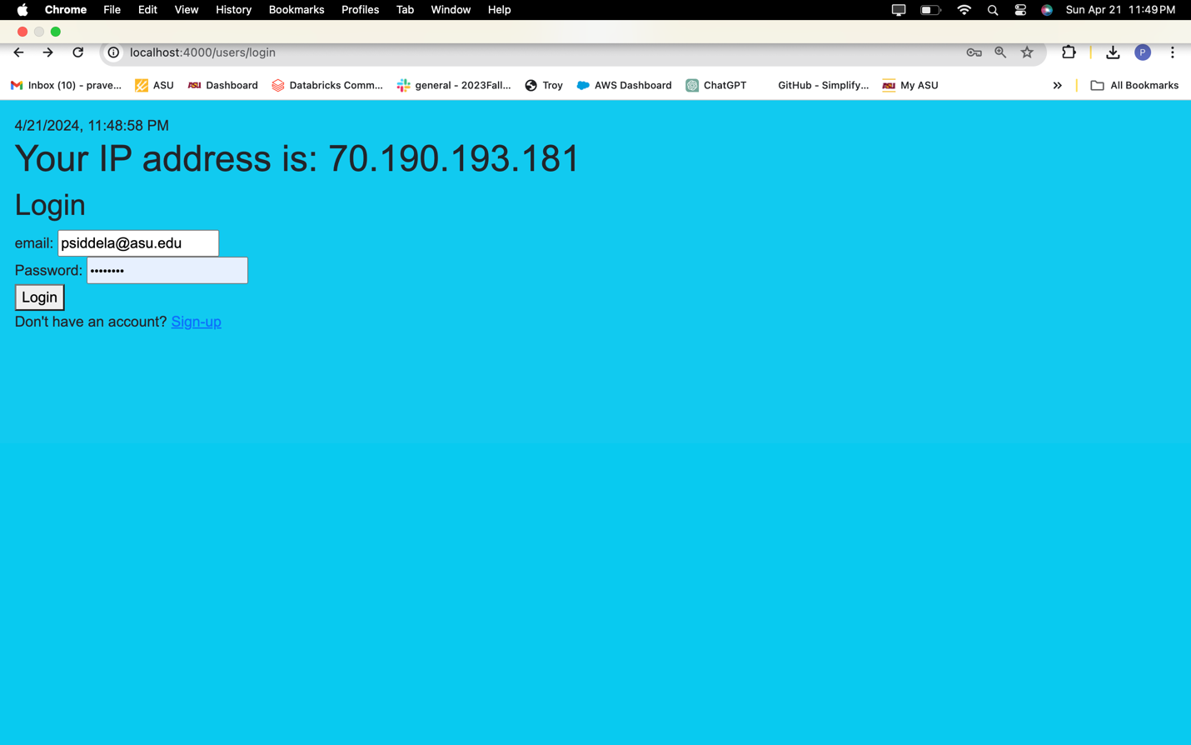

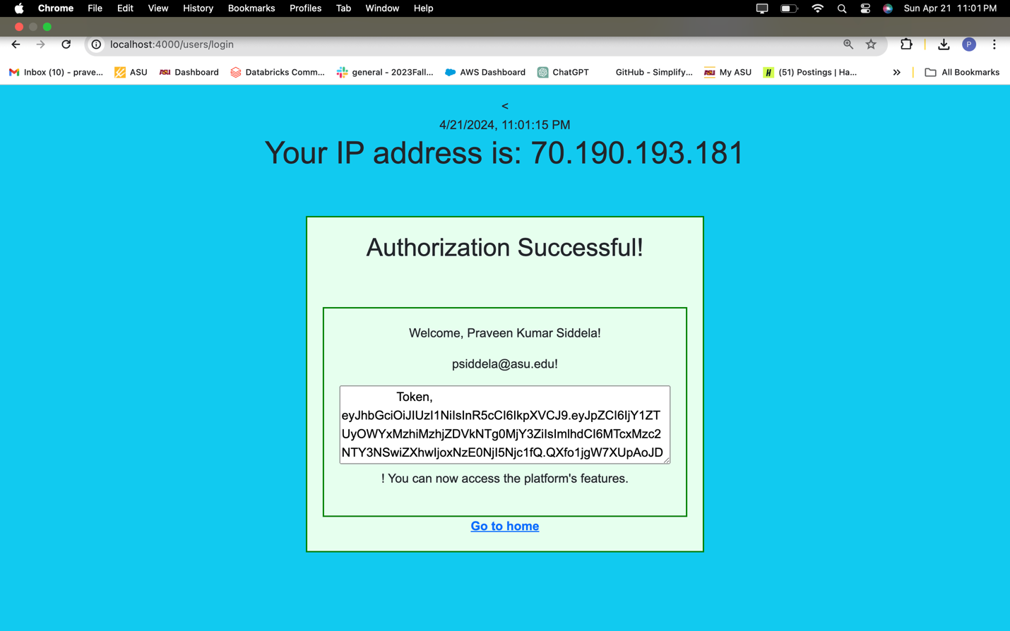

**Retrieve All Books:**

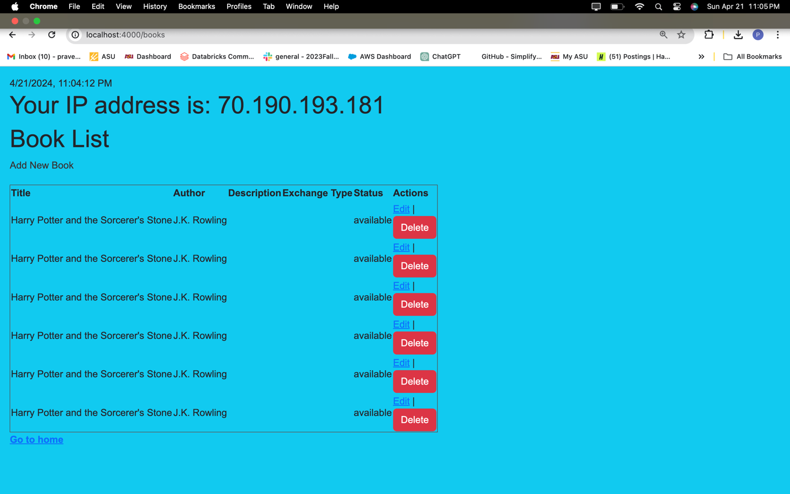**Add New Book:**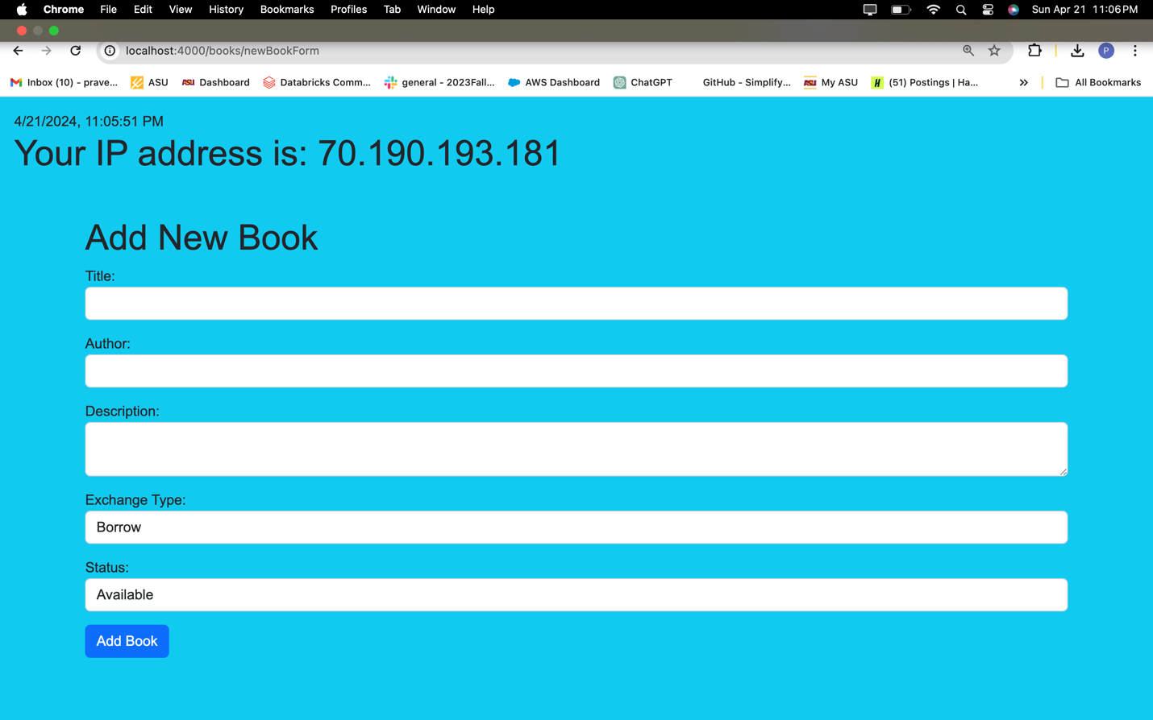

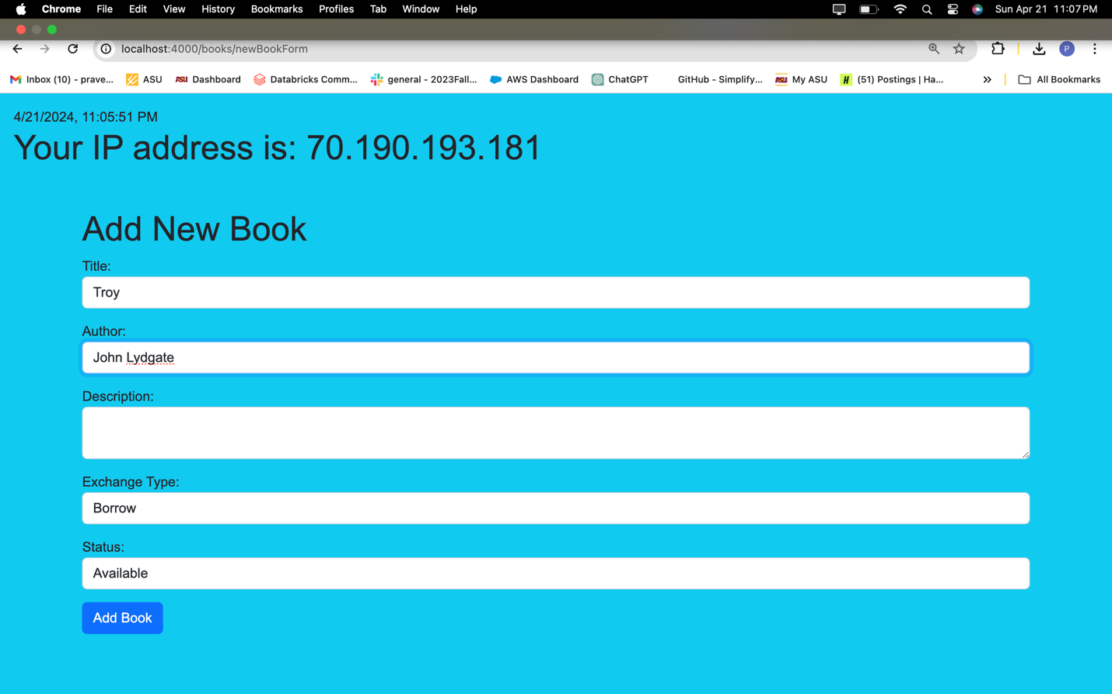

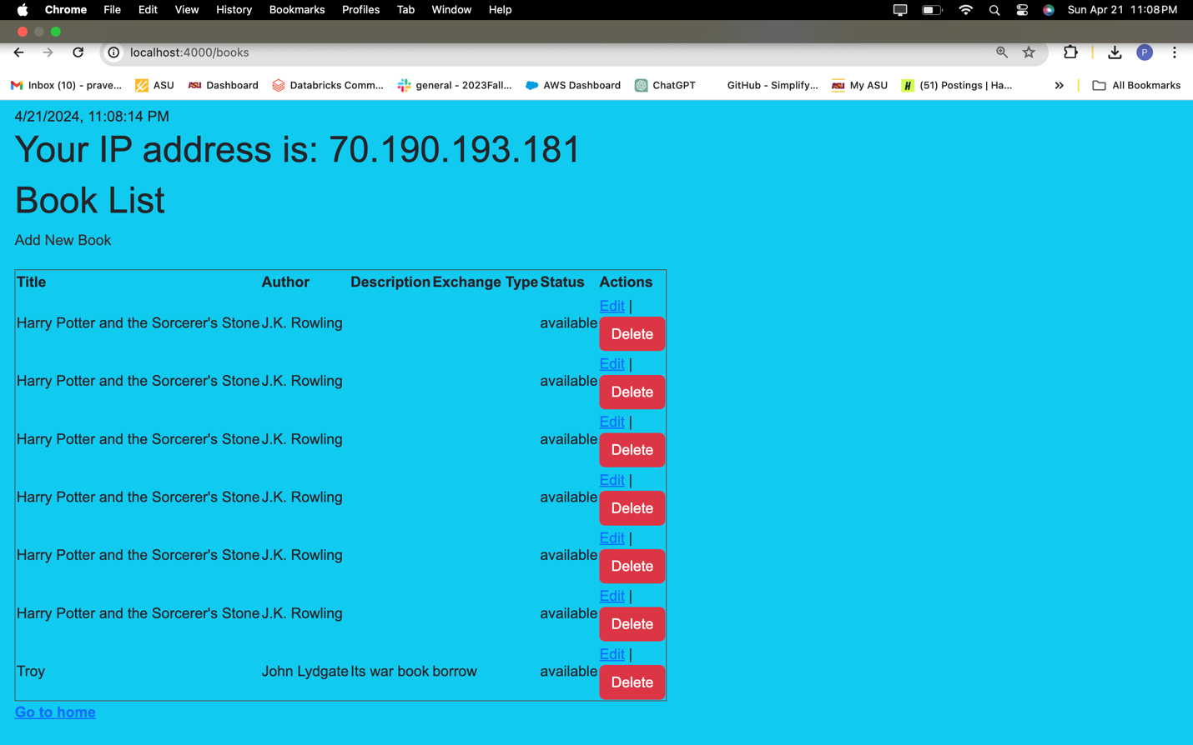

**Edit of the books:**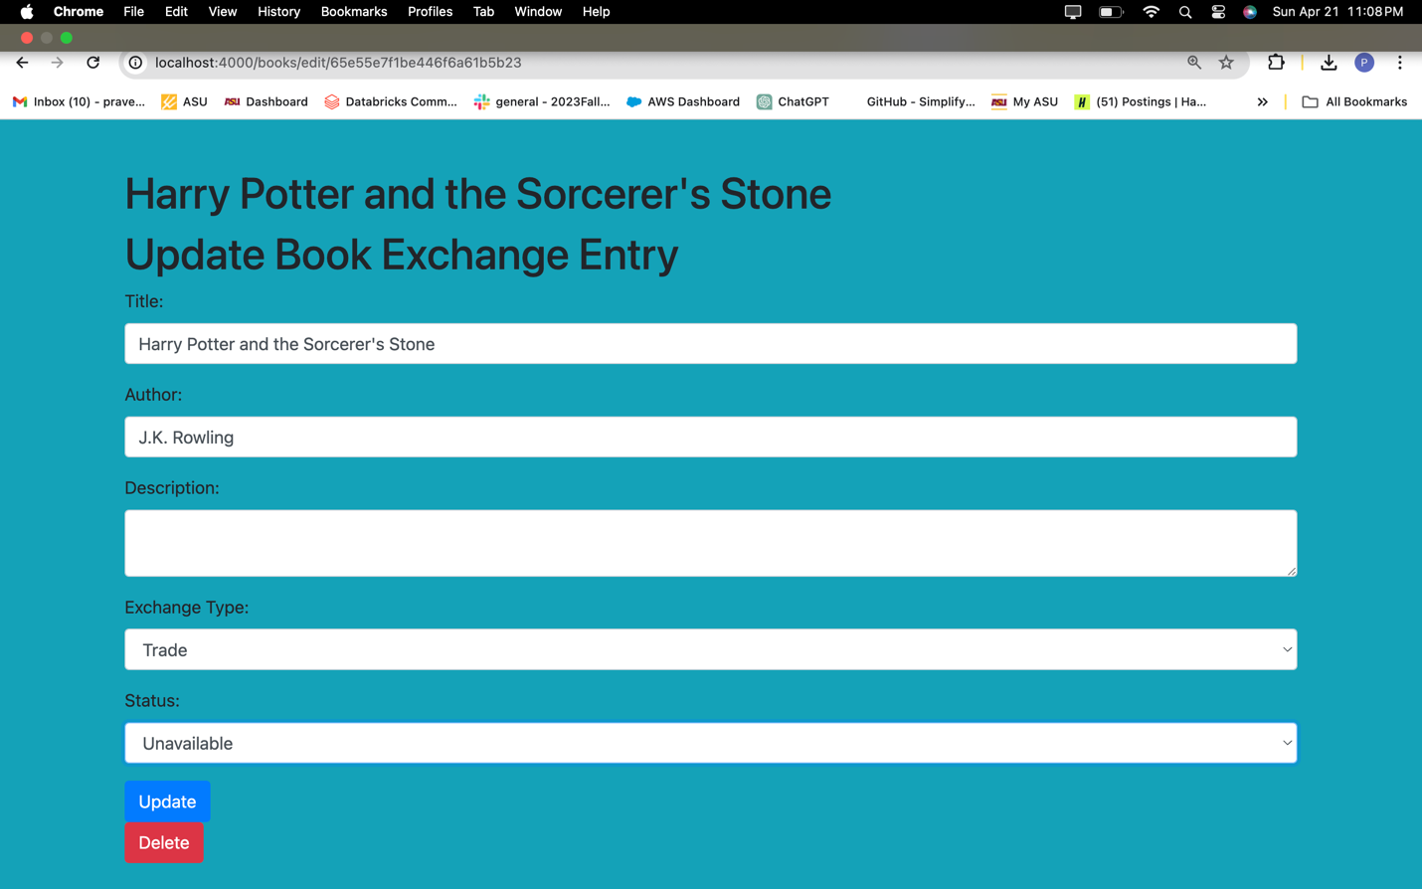

**Deletion of Books:**

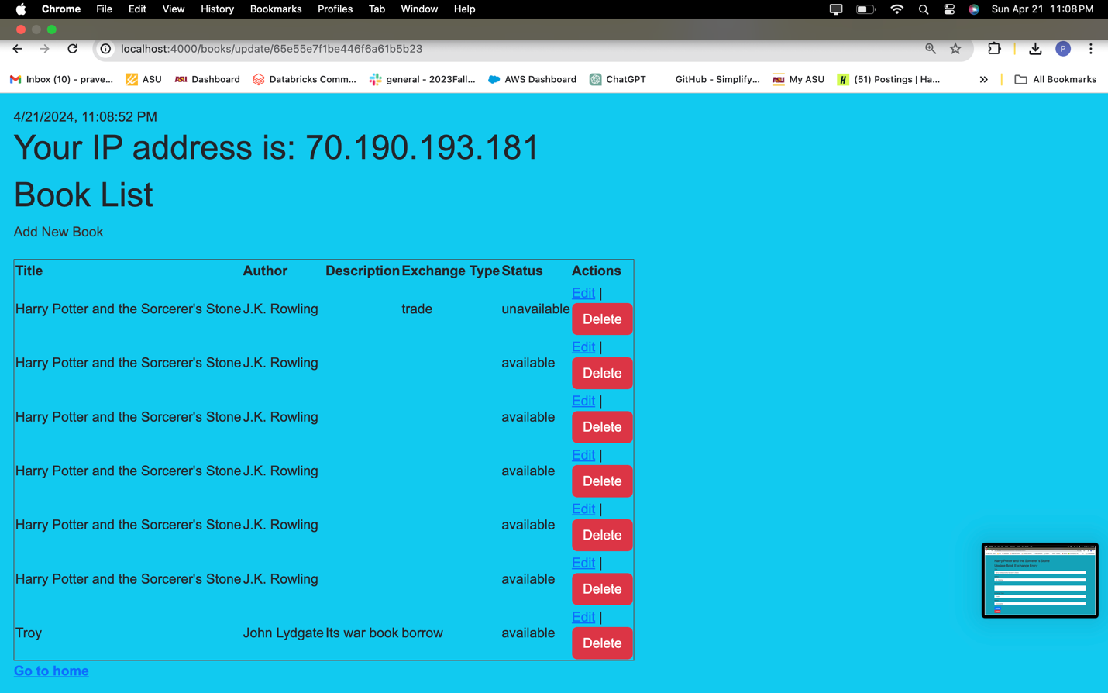

**After Deletion:**

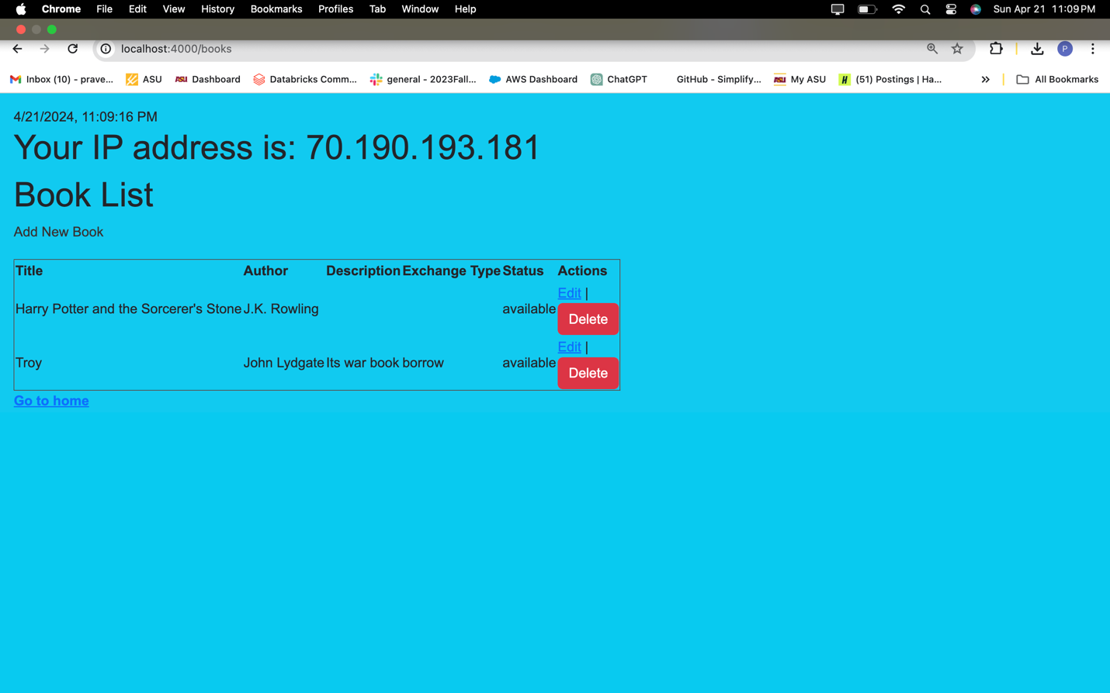

**Screenshot 9**: Of the testing process and responses for different API endpoints.

|  |  |  |
| --- | --- | --- |
| Feature | Method | URL End Point (the following are just the sample) You must update the URLs with the correct endpoints) |
| Register / Sign up | POST | <https://localhost:4000/users/signup> |
| Login | POST | <https://localhost:4000/users/login> |
| Protected Resource | GET | <https://localhost:4000/books> |
| View All Books | GET | <https://localhost:4000/books> |
| Add Book Exchange | POST | <https://localhost:4000/books/newBookForm> |
| Update Delete Exchange | POST | <http://localhost:4000/books/edit/65e565c188ab31ac49627500> |
|  |  |  |

**Screenshot 10**: Of API specification documentation and screenshots of the corresponding code for each endpoint.

**Post:Adding a New Book**

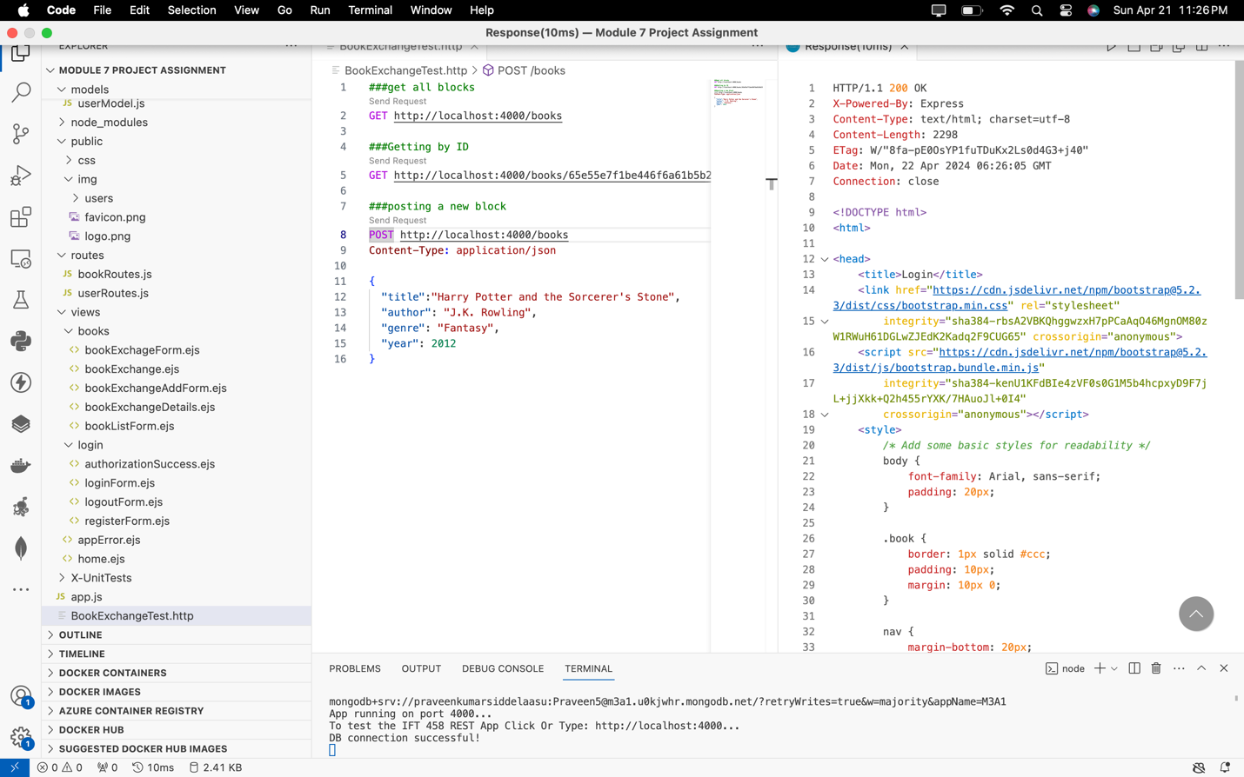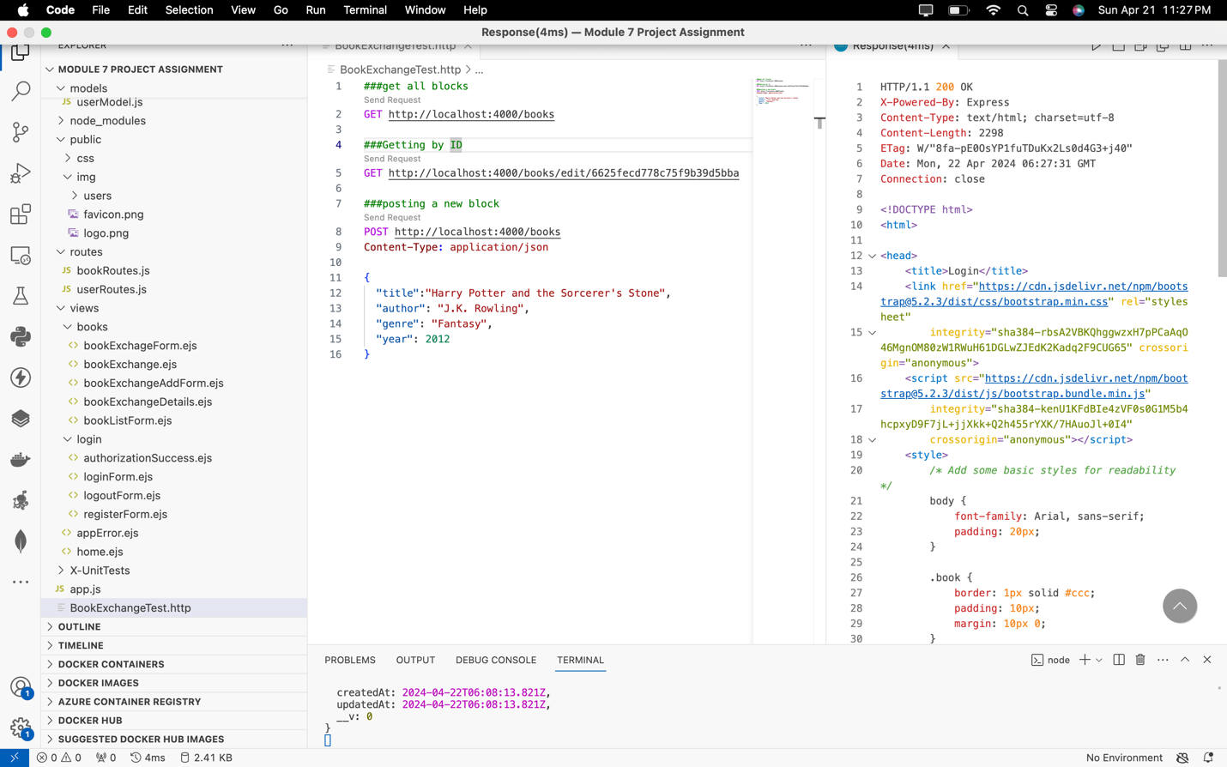



**Get Request:Retrieve all Books**

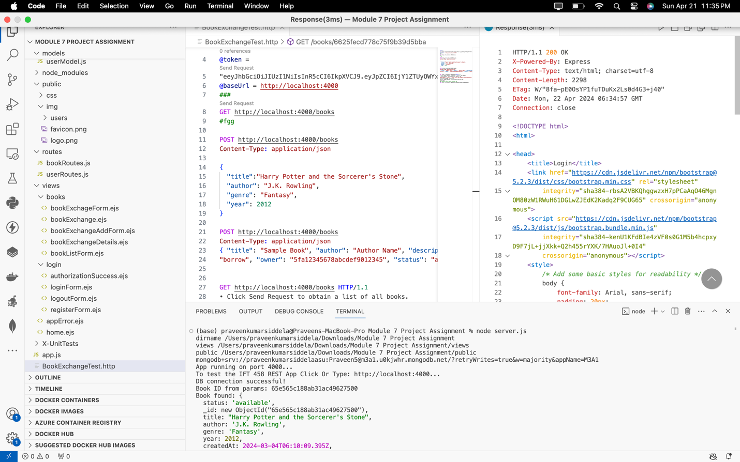



**GET Request: Fetch Specific Book by ID:**

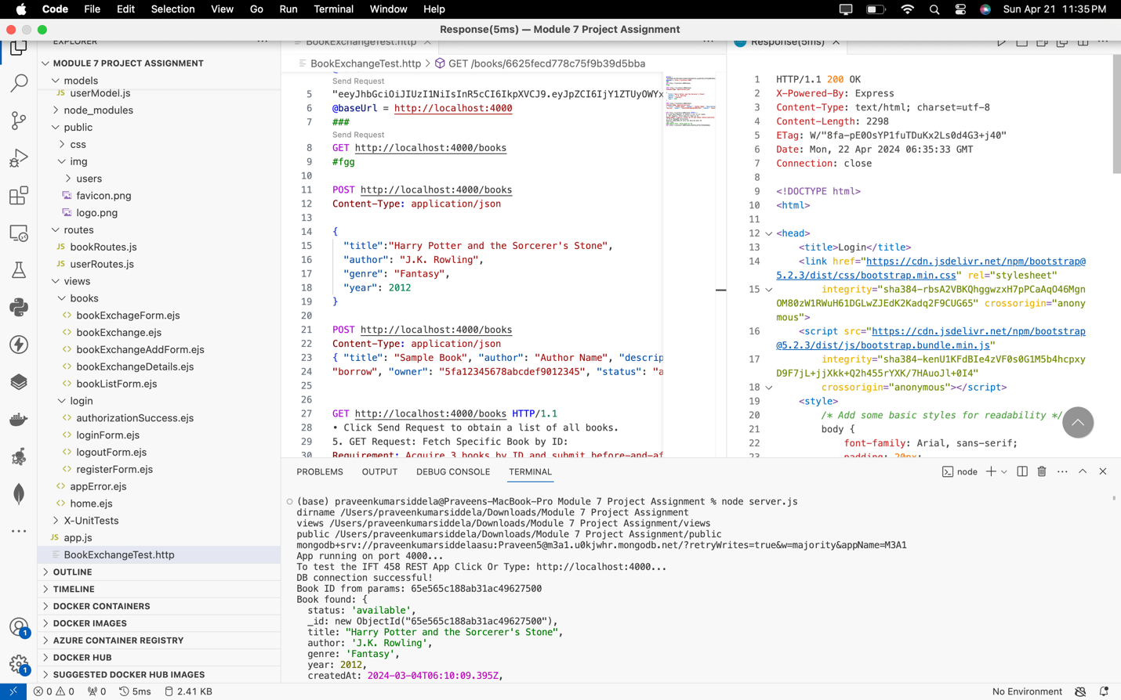

**PUT Request: Modify a Specific Book by ID:**

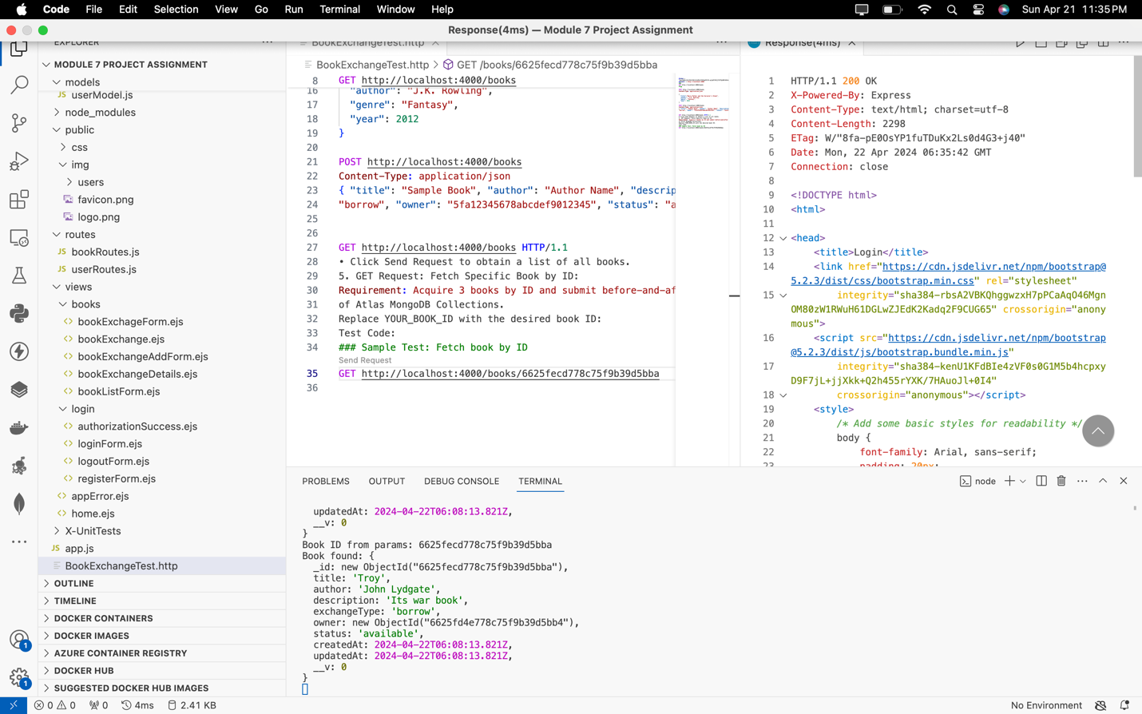

**Learning Outcomes of Module 4 to Module 7**

**Technical Learning Outcomes:**

**Module 4**

In web applications, authentication and authorization are pivotal for ensuring secure user interactions. Authentication verifies users' identities using credentials like usernames and passwords, while authorization determines the actions users are allowed to take post-authentication. Session management is equally critical, as it maintains stateful information about user interactions, encompassing the creation, storage, and secure disposal of session data. Token-based authentication is a prevalent method, issuing tokens to authenticated users for subsequent authorization requests, with JSON Web Tokens (JWT) commonly employed due to their secure and efficient data transmission.

Testing RESTful APIs is imperative to guaranteeing their reliability and functionality. Integrated Development Environment (IDE) tools like Visual Studio Code offer REST client plugins, enabling direct API testing with simple syntax for interacting with various endpoints using standard HTTP methods. Additionally, debugging Node.js applications is vital for swiftly identifying and rectifying errors. IDEs provide debugging tools allowing developers to set breakpoints, pause code execution, and inspect variables and states, streamlining the debugging process for efficient troubleshooting. Protecting application resources involves implementing robust access controls and token expiry mechanisms, alongside session persistence techniques like cookies or local storage, ensuring secure user interactions and seamless experiences.

**Top of Form**

**Bottom of Form**

**Module 5**

Installing Git and Visual Studio Code is the first step in establishing a robust development environment, enabling version control and efficient project management. Cloning repositories allows developers to create local copies of remote codebases, fostering local development and facilitating collaboration with team members. Making changes to code, whether it involves editing existing files, adding new features, or removing unnecessary code, is essential for project progression and improvement. Staging and committing changes with descriptive messages ensures an organized version history, aiding in tracking project evolution and facilitating collaboration among team members.

Pushing changes to the remote repository enables synchronization between local and remote codebases, ensuring seamless collaboration and sharing of progress across the team. Branching out from the main codebase allows developers to isolate work on specific features or fixes, promoting development flexibility and minimizing conflicts. Middleware implementation in Node.js intercepts and processes incoming requests, facilitating tasks such as logging and authentication, thereby enhancing the functionality and security of web applications. Finally, opening pull requests initiates discussions, facilitates code review, and integrates proposed changes into the main repository, promoting collaboration and ensuring code quality and consistency across the project.

**Module 6**

Chained middleware enables the sequential execution of multiple middleware functions, allowing for modular and organized request processing in Node.js applications. Custom middleware development is crucial for addressing specific tasks such as logging and authentication, tailoring middleware functions to meet the application's unique requirements. Middleware error handling plays a vital role in enhancing application reliability by implementing middleware to catch errors and send appropriate responses, ensuring smooth user experiences and preventing potential system failures. Verifying Docker, Node.js, and Visual Studio Code installations is essential for setting up the development environment, ensuring compatibility and readiness for containerization and application development processes. Writing a Docker file and building Docker images within Visual Studio Code streamlines the process of Docker image creation, facilitating efficient deployment and management of containerized applications. Running Docker containers and configuring settings allows developers to manage containerization effectively, ensuring optimal performance and resource utilization while accessing the deployed Node.js app.

Handling dynamic parameters in routes through dynamic routing mechanisms enhances the flexibility and scalability of web applications, accommodating varying user inputs and requirements. Middleware for request validation is crucial for ensuring data integrity and security by validating URL parameters and responding to errors appropriately, safeguarding against malicious inputs and potential vulnerabilities. Implementing complex middleware chains tailored to route-specific tasks allows for intricate request processing and handling in Node.js applications, enabling robust and efficient application behavior. Lastly, error handling middleware plays a crucial role in managing various error types, ensuring graceful degradation and consistent performance even in the face of unexpected issues, thereby enhancing the reliability and resilience of the application.

**Module 7**

To ensure secure communication in a Windows environment, OpenSSL installation is essential, providing a toolkit for SSL/TLS protocols. Generating a self-signed SSL certificate and private key using OpenSSL enables secure connections for applications. Configuring an HTTPS server in a Node.js application with the generated SSL certificate and private key ensures encrypted communication, enhancing data security. Implementing HTTP status codes like 200, 201, 400, 404, and 500 allows for precise server responses, improving user experience and troubleshooting. Developing custom error handling middleware, including 404 (Not Found) and general server errors, ensures robust error management and graceful degradation. Using try/catch blocks with Promises facilitates graceful error handling during asynchronous operations, enhancing application reliability.

For a secure middleware and backend database setup in a Book Exchange Application, organizing the project directory structure according to the Model-View-Controller (MVC) pattern ensures a clear separation of concerns. Reviewing the book model schema and relationships for storing book information in the backend database provides insights into data organization. Implementing logic for CRUD operations related to books in the backend through the book controller enhances data management and manipulation capabilities. Defining routes for handling HTTP requests related to book resources establishes endpoints for CRUD operations, facilitating communication between the frontend and backend. Customizing view templates (*.ejs files) in the view folder personalizes the user interface and enables interaction with backend APIs. Configuring database connections, starting the server, and testing API functionality using tools like Postman or Thunder Client ensures proper application execution and functionality verification.

**References**

[**https://medium.com/@dushyanthak/best-practices-for-writing-custom-middlewares-in-asp-net-core-97b58c50cf9c**](https://medium.com/@dushyanthak/best-practices-for-writing-custom-middlewares-in-asp-net-core-97b58c50cf9c)

[**https://stackoverflow.com/questions/62398/what-are-the-best-practices-for-the-middleware-api**](https://stackoverflow.com/questions/62398/what-are-the-best-practices-for-the-middleware-api)

[**https://www.omnitas.com/how-to-choose-the-right-middleware-for-enterprise-integration/**](https://www.omnitas.com/how-to-choose-the-right-middleware-for-enterprise-integration/)

**Appendices**

1. **Sample Code Snippets:**
   * Views (bookExchange.ejs)
   * Server (server.ejs)
   * Controller(booksController.js)
2. **Screenshots:**

* Updated view files (*.ejs) and changes made
* BookModel.js file and explanation
* Home page displayed in the browser
* Personalized user interface pages
* Testing process and responses for different API endpoints captured in Postman
* Project directory structure showcasing MVC organization
* Architecture diagram showcasing the components and their interactions
* Flowchart illustrating the flow of the Book Exchange Application
* Terminal showing successful installation of dependencies
* bookController.js with implemented logic
* bookRoutes.js file with defined routes

Top of Form

Bottom of Form

1. **Configuration Files:**

Configuration file (config.env) containing database connections and JWT parameters.

Server.js script setting up an HTTPS server in Node.js.

Top of Form

Bottom of Form

1. **API Specification:**

• API documentation detailing the endpoints, request methods, and expected data formats.

• Table presenting the Book Exchange API Specifications, containing endpoint specifics and descriptions gathered during testing.